МИНИСТЕРСТВО ОБРАЗОВАНИЯ И НАУКИ РЕСПУБЛИКИ БУРЯТИЯ

ГБПОУ «КОЛЛЕДЖ ТРАДИЦИОННЫХ ИСКУССТВ НАРОДОВ ЗАБАЙКАЛЬЯ»

Горобец С.И.

МЕТОДИЧЕСКИЕ УКАЗАНИЯ
ДЛЯ СТУДЕНТОВ
ПО ВЫПОЛНЕНИЮ ПРАКТИЧЕСКИХ ЗАДАНИЙ

УЧЕБНАЯ ДИСЦИПЛИНА
АНГЛИЙСКИЙ ЯЗЫК

35.02.07 Механизация сельского хозяйства
54.02.02 Декоративно – прикладное искусство и народные промыслы (по видам)
54.01.13 Изготовитель художественных изделий из дерева»
35.01.23 «Хозяйка усадьбы»

Иволгинск
2021

Методические указания по выполнению практических заданий по учебной дисциплине Английский язык для студентов СПО по специальностям:
35.02.07 Механизация сельского хозяйства, 54.02.02 Декоративно – прикладное искусство и народные промыслы (по видам), 54.01.13 Изготовитель художественных изделий из дерева», 35.01.23 «Хозяйка усадьбы».

Содержание
Введение.……………………………………… ........................ 6 стр
Тематическое планирование.............................. ...................... 7 – 5
Практическая работа № 1…………………………………........ 9 - 21.
Практическая работа № 2 …………...……………………….… 2 - 24
Практическая работа № 3 ……………………………………… 5 – 26
Практическая работа № 4 ……………………………………… 27 - 3
Практическая работа № 5…………………………………......... 31 - 34
Практическая работа № 6 …………………………………….… 5 - 37
Практическая работа № 7…………………………………….… 38 - 41
Практическая работа № 8………………………………….…… 42 - 43
Практическая работа № 9 ………………………………….…… 44 - 45
Практическая работа № 10 ……………………………….…….. 46 - 50.
Практическая работа № 11………………………………..………51
Практическая работа № 12………………………………….….…52 -55
Практическая работа № 13 ………………………………...........56 - 58
Практическая работа № 14………………………………….…….59 - 62
Практическая работа № 15………………………………….….....63 - 64
Практическая работа № 16……………………………………… 65 - 68
Практическая работа № 17……………………………………… 69 - 71
Практическая работа № 18……………………………………... 72 - 75
Практическая работа № 19…………………………………….... 76 - 78
Практическая работа № 20…………………………………...... 79 - 80
Практическая работа № 21…………………………….............. 81 - 86
Практическая работа № 22……………………………….......... . 87 - 92
Практическая работа № 23………………………….................. 93 - 97
Практическая работа № 24…………………………………....... . 98 - 100
Литература .....................................................................................101

Введение
Основной целью практического курса обучения иностранному языку в колледже является формирование у студентов иноязычной коммуникативной компетенции и развитие личности, способной и желающей овладеть иностранным языком как средством общения и обучения.
Формирование иноязычной коммуникативной компетенции предусматривает отбор, методическую организацию и включение в учебный процесс образцов отечественной и зарубежной культуры. Последнее обусловливает включение в содержание обучения комплекса лингвострановедческих и страноведческих знаний о национально-культурных особенностях и реалиях страны (стран) изучаемого языка (безэквивалентной лексики, фразеологизмов, пословиц, афоризмов, географии и истории, национальных традиций и праздников, других особенностей страны изучаемого языка), минимум этикетных форм иноязычной речи для общения в социально-культурной сфере.
Задачи пособия:
-способствовать выработке у студентов базовых умений и навыков по основным видам речевой деятельности;
-развивать технику чтения и умение понимать аутентичный текст;
-развивать навыки письменной речи.
Содержание учебной дисциплины «Английский язык» направлено на достижение следующих целей:
- формирование представлений об английском языке как о языке международного общения и средстве приобщения к ценностям мировой культуры и национальных культур;
- формирование коммуникативной компетенции, позволяющей свободно общаться на английском языке в различных формах и на различные темы, в том числе в сфере профессиональной деятельности с учетом приобретенного словарного запаса. А также условий, мотивов и целей общения;
- формирование и развитие всех компонентов коммуникативной компетенции: лингвистической, социолингвистической, дискурсивной, социокультурной, социальной, стратегической и предметной;
- воспитание личности, способной и желающей участвовать в общении на межкультурном уровне;
- воспитание уважительного отношения к другим культурам и социальным субкультурам.
В программу включено содержание, направленное на формирование у студентов компетенций, необходимых для качественного освоения ОПОП СПО на базе основного общего образования с получением среднего общего образования, - программы подготовки квалифицированных рабочих, служащих, программы подготовки специалистов среднего звена.
Английский язык как учебная дисциплина характеризуется:
- направленностью на освоение языковых средств общения, формирование новой языковой системы коммуникации, становление основных черт вторичной языковой личности;
- интегративным характером – сочетанием языкового образования с элементарными основами литературного и художественного образования (ознакомление с образцами зарубежной литературы, драматургии, музыкального искусства, кино и др.);
- полифункциональностью – способностью выступать как целью, так и средством обучения при изучении других предметных областей что позволяет реализовать в процессе обучения самые разнообразные межпредметные связи.
Содержание учебной дисциплины направлено на формирование различных видов компетенций:
– лингвистической — расширение знаний о системе русского и английского языков, совершенствование умения использовать грамматические структуры и языковые средства в соответствии с нормами данного языка, свободное использование приобретенного словарного запаса;
– социолингвистической — совершенствование умений в основных видах речевой деятельности (аудировании, говорении, чтении, письме), а также в выборе лингвистической формы и способа языкового выражения, адекватных ситуации общения, целям, намерениям и ролям партнеров по общению;
– дискурсивной — развитие способности использовать определенную стратегию и тактику общения для устного и письменного конструирования и интерпретации связных текстов на английском языке по изученной проблематике, в том числе демонстрирующие творческие способности обучающихся;
– социокультурной — овладение национально-культурной спецификой страны изучаемого языка и развитие умения строить речевое и неречевое поведение адекватно этой специфике; умение выделять общее и различное в культуре родной страны и англоговорящих стран;
– социальной — развитие умения вступать в коммуникацию и поддерживать ее;
– стратегической — совершенствование умения компенсировать недостаточность знания языка и опыта общения в иноязычной среде;
– предметной — развитие умения использовать знания и навыки, формируемые в рамках дисциплины «Английский язык», для решения различных проблем.
Основное содержание предполагает формирование у обучающихся совокупности практических умений, таких как:
- заполнить анкету/заявление (например, о приеме на курсы, в отряд волонтеров, в летний/зимний молодежный лагерь) с указанием своих фамилии, имени, отчества, даты рождения, почтового и электронного адреса, телефона, места учебы, данных о родителях, своих умениях, навыках, увлечениях и т. п.;
- заполнить анкету/заявление о выдаче документа (например, туристической визы);
- написать энциклопедическую или справочную статью о родном городе по предложенному шаблону;
- составить резюме.
Профессионально ориентированное содержание нацелено на формирование коммуникативной компетенции в деловой и выбранной профессиональной сфере, а также на освоение, повторение и закрепление грамматических и лексических структур, которые наиболее часто используются в деловой и профессиональной речи.
При этом к учебному материалу предъявляются следующие требования:
- аутентичность;
- высокая коммуникативная ценность (употребительность), в том числе в ситуациях делового и профессионального общения;
- познавательность и культуроведческая направленность;
- обеспечение условий обучения, близких к условиям реального общения (мотивированность и целенаправленность, активное взаимодействие, использование вербальных и невербальных средств коммуникации и др.).
Организация образовательного процесса предполагает выполнение индивидуальных проектов, участия обучающихся в ролевых играх, требующих от них проявления различных видов самостоятельной деятельности: исследовательской, творческой, практико – ориентированной и др.
Содержание учебной дисциплины «Английский язык» предусматривает освоение текстового и грамматического материала.

ТЕМАТИЧЕСКОЕ ПЛАНИРОВАНИЕ
Практическая работа
Тематика практической работы

Раздел 1. Вводно-коррективный курс
Тема 1.1. Описание людей: друзей, родных и близких и т.д. (внешность, характер, личные качества
Тема 1.2. Межличностные отношения дома, в учебном заведении, на работе
Раздел 2. Развивающий курс
Тема 2.1. Повседневная жизнь, условия жизни, учебный день, выходной день
Тема 2.2. Здоровье, спорт, правила здорового образа жизни
Тема 2.3. Город, деревня, инфраструктура
Тема 2.4. Досуг
Тема 2.5. Новости, средства массовой информации
Тема 2.6. Природа и человек (климат, погода, экология)
Тема 2.7. Образование в России и за рубежом, среднее профессиональное образование
Тема 2.8. Культурные и национальные традиции, краеведение, обычаи и праздники
Тема 2.9. Общественная жизнь (повседневное поведение, профессиональные навыки и умения)
Тема 2.10. Научно-технический прогресс
Тема 2.11. Профессии, карьера
Тема 2.12. Отдых, каникулы, отпуск. Туризм
Тема 2.13. Искусство и развлечения
Тема 2.14. Государственное устройство, правовые институты
Раздел 3. Общение (устное и письменное) на иностранном языке на профессионально направленные темы.
Тема 3.1. Документы (письма, контракты
Тема 3.2. Планирование времени (рабочий день
Тема 3.3. Условия проживания, система социальной помощи
Тема 3.4. Межличностные отношения
Тема 3.5. Профессии и профессиональные качества, профессиональный рост, карьера
Тема 3.6. Интернет
Тема 3.7. Страноведение
Тема 3.8. Музыка, литература, писатели.

Практическая работа №1

Тема 1.1. Описание людей: друзей, родных и близких и т.д. (внешность, характер, личные качества)

Цель: совершенствование и развитие произносительных навыков, а также же навыков чтения, письменной и устной речи на английском языке. Научить описывать людей.

Задание 1. Прочитайте следующие слова, отрабатывая звучание долгих и кратких гласных:
[i:] – we [wi:] мы, he [hi:] он, she [ʃi:] она, eat [i:t] питаться, seat [si:t] место для сиденья, be[bi:] быть, see [si:] видеть, three [θri:] три, people [pi:pl] люди, peace [pi:s] мир, free [fri:] свободный, teach [ti:tʃ] обучать, speak [spi:k] говорить, queen [kwi:n] королева.
[ɪ] – it [ɪt] оно, это, this [ðɪs] этот, sit [sɪt] сидеть, if [ɪf] если, live [lɪv] жить, begin [bɪʹɡɪn] начинать, invest [ɪnʹvest] вкладывать (капитал), Britain [ʹbrɪt(ə)n] Британия, English [ʹɪŋɡlɪʃ] английский язык, different [dɪfr(ə)nt] различный, king [kɪŋ] король.
[e] – men [men] люди, when [wen] когда, end [end] конец, health [helθ] здоровье, guest[ɡest] гость, ten [ten] десять, Wednesday [ʹwenzdɪ] среда, spend [spend] проводить, every[ʹevrɪ] каждый.
[æ] – man [mæn] человек, can [kæn] мочь, map [mæp] карта, land [lænd] земля, that [ðæt] тот, travel [ʹtrævəl] путешествие, Saturday [ʹsætədɪ] суббота, manners [ʹmænəz] (хорошие) манеры.
[ɑ:] – car [kɑ:] автомобиль, far [fɑ:] далеко, France [frɑ:ns] Франция, chance [tʃɑ:ns] шанс,father [ʹfɑ:ðə] отец, after [ʹɑ:ftə] после.
[ʌ] – one [wʌn] один, but [bʌt] но, must [mʌst] должен, London [ʹlʌndən] Лондон, come[kʌm] приходить, mother [ʹmʌðə] мать, above [əʹbʌv] выше, Sunday [ʹsʌndɪ] воскресенье,Monday [ʹmʌndɪ] понедельник, some [sʌm] некоторые, country [ʹkʌntrɪ] страна.
[ɔ:] – sport [spɔ:t] спорт, or [ɔ:] или, daughter [ʹdɔ:tə] дочь, four [fɔ:] четыре, for [fɔ:] для,horse [hɔ:s] лошадь, before [bəʹfɔ:] перед, all [ɔ:l] все, formal [ʹfɔ:ml] официальный, North[nɔ:θ] север.
[ɔ] – spot [spɔt] пятно, from [frɔm] из, от, was [wɔz] был, sorry [sɔrɪ] сожалеющий, hot [hɔt] горячий, shock [ʃɔk] шок, what [wɔt] что, clock [klɔk] часы, watch [wɔtʃ] часы, Scotland[ʹskɔtlənd] Шотландия.
[u:] – you [ju:] ты, do делать [du:], too [tu:] также, two [tu:] два, group [gru:p] группа, who[hu:] кто, soon [su:] скоро, choose [tʃu:z] выбирать, Tuesday [ʹtju:zdɪ] вторник, school [sku:l] школа.
[u] – full [ ful] полный, put [put] класть, good [gud] хорошо, push[puʃ] толкать, pull [pul] тянуть, book [buk] книга, look [luk] смотреть, foot [fut] нога.
[ə:] – girl [ɡə:l] девочка, work [wə:k] работа, world [wə:ld] мир, term [tə:m] семестр, learn[lə:n] изучать, Thursday [ʹθə:zdɪ] четверг, earth [ə:θ] земля, Sir [sə:] сэр.
[ə] – sister [ʹsɪstə] сестра, teacher [ʹti:tʃə] учитель, Russia [ʹrʌʃə] Россия, attend [əʹtend] посещать, surprise [səʹpraɪz] удивляться, сюрприз, America [əʹmerɪkə] Америка, England[ʹɪŋɡlənd] Англия, kingdom [kiŋdəm] королевство.
Задание 2. Прочитайте слова, отрабатывая звучание дифтонгов (двугласных), которые представляют собой как бы два слитно произнесенных гласных с ударением на первом элементе:
[eɪ] – they [ðeɪ] они, way [weɪ] путь, дорога, способ, day [deɪ] день, name [neɪm] имя, называть, stage [steɪdʒ] стадия, сцена, face [feɪs] лицо, aim [eɪm] цель, paper [ʹpeɪpə] бумага, газета, stay [steɪ] оставаться, say [seɪ] говорить, сказать, same [seɪm] тот же самый, Wales [weɪlz] Уэльс, great [greɪt] большой, огромный.
[aɪ] – I [aɪ] я, my [maɪ] мой, myself [maɪʹself] сам, eye [aɪ] глаз, guide [ɡaɪd] гид, проводник,die [daɪ] умирать, Friday [ʹfraɪdɪ] пятница, child [tʃaɪld] ребенок, why [waɪ] почему, primary[ʹpraɪmərɪ] первостепенный, начальный, private [praɪvɪt] частный.
[au] – now [nau] сейчас, how [hau] как, out [aut] вне, из, about [əʹbaut] около, down [daun] вниз, house [haus] дом, ground [ɡraund] земля, town [taun] город, South [sauθ] Юг.
[ɔɪ] – boy [bɔɪ] мальчик, oil [ɔɪl] масло, toilet [tɔɪlɪt] туалет, choice [tʃɔɪs] выбор, join [dʒɔɪn] соединять(ся), employ [ɪmʹplɔɪ] нанимать на работу, использовать.
[əu] – no [əu] нет, home [həum] дом, know [nəu] знать, cold [kəuld] холодный, road [rəud] дорога, low [ləu] низкий, only [ʹəunlɪ] только, nobody [ʹnəubodɪ] никто.
[ɪə] – ear [ɪə] ухо, near [nɪə] близко, clear [klɪə] ясный, чистый, theatre [ʹθɪətə] театр, real[rɪəl] реальный, ideal [aɪʹdɪəl] идеальный, zero [ʹzɪərou] ноль.
[ɛə] – air [ɛə] воздух, chair [tʃɛə] стул, there [ðɛə] там, their [ðɛə] их, where [wɛə] где, куда,parents [ʹpɛərənts] родители.
[uə] – tour [tuə] тур, путешествие, sure [ʃuə] уверенный, poor [puə] бедный, pure [pjuə] чистый, cure [kjuə] лечение, лекарство, during [ʹduərɪŋ] во время, mutual [ʹmju:tʃuəl] взаимный, usual [ʹju:ʒuəl] обычный, plural [ʹpluərəl] множественный.
Задание 3. Прочитайте слова, отрабатывая звучание трифтонгов, т.е. сочетаний дифтонгов с нейтральной гласной фонемой [ə]:
[eɪə] – player [pleɪə] игрок, layer [leɪə] слой, пласт, prayer [preɪə] проситель, молящийся.
[aɪə] – fire [faɪə] огонь, iron [aɪən] железо, утюг, society [səʹsaɪətɪ] общество, dialogue[ʹdaɪəlɔɡ] диалог, shire [ʃaɪə] графство, higher [haɪə] выше, via [vaɪə] через, Ireland [ʹaɪələnd] Ирландия, science [ʹsaɪəns] наука, variety [vəʹraɪətɪ] разнообразие.
[auə] – our [auə] наш, hour [auə] час, flower [flauə] цветок, tower [tauə] башня, towel [tauəl] полотенце, shower [ʃauə] душ, nowadays [nauədeɪz] сейчас, сегодня, power [pauə] сила, власть.
[əuə] – slower [sləuə] медленнее, ower [əuə] должник, goer [gəuə] ходок, follower [ʹfɔləuə] последователь, поклонник.
[ɔɪə] – employer [ɪmʹplɔɪə] работодатель, royal [rɔɪəl] королевский, roalist [ʹrɔɪəlɪst] роялист,destroyer [dɪʹstrɔɪə] разрушитель.
Правила чтения гласных в разных типах чтения
Чтение гласной буквы в ударном слоге зависит от типа слога. Принято делить 4 типа слога:
I тип – открытый слог (т.е. слог, оканчивающийся на гласную букву);
II тип – закрытый слог (т.е. слог, оканчивающийся на согласную букву);
III тип – слог с буквой r (т.е. ударная гласная + r);
IV тип – слог с сочетанием re (т.е. ударная гласная + re).

Типы слога
I II III IV
A
a [eɪ] name [æ] lamp [ɑ:]park [ɛə]fare
O
o[əu] ago note [ɔ]not [ɔ:]sport ɔ:]more
E e
[i:] me [e] pen [ɜ:]her [ɪə] here
I i/ Y y
[aɪ] like type [ɪ] big myth [ɜ:]girl [aɪə] fire tyre
U u
[ju:] tune [ʌ] bus [ɜ:] turn [juə] pure[ə] success, [ju:]unite
Задание 4. Прочитайте следующие слова по вертикали, а затем по горизонтали, отрабатывая правила чтения гласных в различных типах слога.
Aa
[eɪ] [æ] [ɑ:] [ɛə] [ə]
Lame, gave, late, made, game, hate, am, back, land, apple, man, hat, dark, car, bark, ,card, far, care, dare, bare, rare, share, declare, ago, about, sofa, above, historical, legal.
Oo
[əu] [ɔ] [ɔ:] [ɔ:] [ə] [əu]
Home, hope, go, rose, nose, open, god, on, dog, shop, clock, cod, or, nor, port, short, lord, order, ore, store, shore, core, bore, before, tomato, photo, potato, negro, zero, metro.
Ee
[i:] [e] [ɜ:] [ɪə] [ə] [ɪ]
He, she, we, see, week, agree, get, egg, let, ten, men, tent, term, verb, nerve, serve, prefer, person, mere, sphere, severe, career, period, material, begin, return, ticket, sister, present, absent.
Ii/ Yy
[aɪ] [ɪ] [ɜ:] [aɪə] [ɪ]
I, time, five, my, fly, cry, it, ill, milk, wish, myth, symbol, sir, bird, first, dirty, Byrn, myrtle, hire, wire, tire, satire, tired, lyre, engine, sorry, family, music, public, English.
Uu
[ju:] [ʌ] [ɜ:] [juə] [ə] [ju:]
Due, tube, use, union, student, pupil, but, cup, under, fun, butter, sun, fur, burn, nurse, purple, return, Turkey, cure, lure, during, curious, secure, endure, success, difficult, upon, product, cucumber, luxury
Задание 5. Прочитайте следующие слова и сгруппируйте их в 4 колонки по правилам чтения гласных букв в ударном слоге.
Rome, summer, China, art, spring, duty, try, well, bore, time, severe, term, spoke, store, parents, enter, tired, winter, whole, spire, plane, short, be, atmosphere, hard, supper, smoke, alert, fond, plan, burst, wish, farm, compare, came, corn, dirt, tree, human, hurt, fell, miss, North, fare, hope, satire.
Задание 6. Прочитайте и переводите текст.
First of all I want to tell you that my best friend's name is Irina and she is 15. She is the best person I have ever met.
A few words about her appearance. Her height is nearly 149 cm. But she'd like to be a bit taller. Well, she is not slim but she is not fat either.
Irina has a round face as everyone has, a bit long nose and big cheerful grey eyes. Her skin is a bit pale but she likes this fact, she doesn't like ruddy faces. She has no freckles as my friend Nina has. Her forehead is open. I think Irina has a charming smile.
Her hair isn't very short but it's not long either. It is straight and black. Irina has rich hair.
I think that she looks like her father.
Irina is very active and creative, cheerful and curious. But the best thing is that she is reliable. We spend much time together. We go for a walk, we play tennis, watch TV, do things which we like. I love my friend.
Vocabulary
body build - телосложение
figure - фигура
slim - стройная
little, small - маленькая
thin – худая
tall - высокий
short - низкого роста.
fat - тучный, толстый
large, big - большая
stooping - сутулая
beautiful - красивое (о женщине)
handsome - красивое (о мужчине)
face – лицо
oval - овальное,
round - круглое
square - квадратными
freckles - веснушки.
wrinkles – морщины
ruddy - румяное
pale - бледное
pretty, nice - приятное, симпатичное
plain - некрасивое
ugly - уродливое
horrible - ужасное
thin - худое
hair - волосы
black - черные
red - рыжие
grey - седые.
blond(e) блондин
fair - белокурые
brown - шатен
brunette - брюнет .
long - длинные,
short - короткие,
shoulder-lenght - до плечей,
bald - лысый, с лысиной
straight - прямые,
curly - кудрявые, вьющиеся.
rich, thick - густые волосы
thin - редкие
nose - нос
straight - прямой
snub - курносый
aquiline - орлиный
flat - приплюснутый
. eyes - глаза
narrow - узкими
big - большие
brown - карие
green - зеленые
blue - голубые,
dark - черные.
lips - губы
thin - тонкими
thick - толстые
chin - подбородок
dimpled - с ямочкой (подбородок),
flat - плоский ,
pointed - острый,
square - квадратный,
protruded - выступающий.
forehead - лоб
high - высокий
open - открытый
narrow - узкий
low - низкий
broad - широкий
skin – кожа
cream-white - белоснежная
sunburnt / tanned - загорелая
sluggish – дряблой
features of character – черты характера
clever - умный
bright – сообразительный
talented – талантливый
stupid / foolish – глупый
optimistic – оптимист
pessimistic – пессимист
nervous – нервный
weak – слабый
strong - сильный
gregarious – общительный
cruel - злой
polite - вежливый
rude – грубый
reliable - надежный
kind - добрый
amiable - любезный
considerate - внимательный
shy - застенчивый,
jolly - весёлый
serious - серьёзные
Задание 7. Прочитайте и переводите текст.
As you know people from different countries do not look the same. For example, people from countries such as Denmark, Norway and Sweden are usually tall. They have fair hair, blue eyes and a pale complexion.
Most people in Mediterranean countries such as Italy, Spain and Greece are rather short. They have usually got black or dark brown wavy hair, brown eyes and light brown skin.
Most people from central and southern parts of Africa have got black curly hair and very dark skin. They have also got dark brown eyes, full lips and a wide, flattish nose.
People from Arab countries such as Saudi Arabia, Iraq and Libya have usually got dark hair and dark brown eyes. They have also got dark skin.
The northern Chinese are quite short, with thick black hair and dark, slanting eyes. They have got a small nose and a yellowish complexion.
Those who live in hot countries wear light clothes like shorts, T-shirts and slippers. People from northern countries such as Canada, Russia and Finland wear too much clothes in winter – coats, hats, scarves, winter boots and other warm things.
In my opinion character does not depend on appearance. So, a very beautiful girl can be angry, nervous person who hates everybody and everything. But an ugly plump person can be really nice and friendly. It can be a good friend, who can always help you. So I advice everybody not to judge people by their appearance.
Задание 8. Темы для устного сообщения.
Describe your mother/father.
Describe the portrait of any star.
You met a wonderful man on the street. Tell about him.
You have never met your uncle before. Your father tells you about him.
Tell about your pet’s (cat, dog) character.

Практическая работа №2

Тема 1.2. Межличностные отношения дома, в учебном заведении, на работе
Цель: совершенствование и развитие навыков устной и письменной речи, навыков чтения и перевода текста профессиональной направленности на английском языке.
My Friends

We meet a lot of people during our lives. We communicate with all these people, but our attitudes towards each of these people are different. Usually I classify people I know as acquaintances, friends and close friends. I'm going to tell you about my best friends. They are Victor and Dmitri.
Victor is a good-natured guy of medium height, strong in body, light-haired with light blue eyes. Usually he is the life and soul of the party. Victor is fond of foreign languages. Not so long ago he decided to study English. He worked on it hard, and now he speaks English well.
Victor also likes music. He is a good singer, he plays mouth organ and dances better than Michael Jackson.
Dmitri is rather slim, not very tall, his hair is brown, his eyes are grey. Usually he wears T-shirts with emblems of football clubs, such as "Dinamo" (Moscow) and "Zenit"(St. Petersburg). He is an enthusiastic football fan.
Dmitri is an extremely sociable person. By means of e-mail he corresponds with many people from different countries. They discuss political and economic issues. Dmitri is also interested in philosophy. He often cites Confucius's utterances.
My friends are very interesting to talk to. They are both very clever and educated guys, they are open-hearted and social, well-mannered and tactful. People usually like them. I'm happy to have such friends as Victor and Dmitri.
1. Give Russian equivalents of the following words and word combinations:
to communicate, attitude, acquaintance, close friend, a good-natured guy, medium height, foreign language, mouth organ, T-shirt, enthusiastic football fan, sociable person, by means of e-mail, to correspond, issue, Confucius's utterances, educated guy, open-hearted.
2. Describe Victor and Dmitri.
Relationship between parents and children
Everyone says that youth is probably the best time of our life. Being young means love, friendship and romance, new discoveries and so on. But we must know that for teenagers it is the most difficult time. That`s why parents must help their children solve youth problems. It can really help construct good relationship between parents and children.
But in our modern life there is often a lack of communication between parents and their children. Lack of the love and attention to children can make them unhappy.
As for me, I get on very well with my parents. Whenever I have problems with my friends or with my schoolwork, I know they are always there to listen and give advice. They have taught me a lot. They have got a lot of experience and they have always happy to share their knowledge with me. But sometimes my Mum and Dad seem to think I`m still a kid. When I go out with friends, I always have to be back home by ten o`clock and they call me on my mobile to check where I am. I have to ask permission for almost everything I do. It doesn`t seem fair sometimes but I anyway love my parents very much and I think they are the kindest in the whole world.
In conclusion, the ability to solve or avoid family problems depends on children and parents. If the relationship between parents and children is based on love, mutual respect, and kindness, the family will be happy.
3. Give Russian equivalents of the following words and word combinations:
Being young means, solve youth problems, a lack of communication, attention to children, get on with smb, advice, to have got a lot of experience, to share knowledge, avoid problems.
4. Use the words and word combinations of exercise 3 in the sentences of your own.
5. Give English equivalents of the following words and word combinations:
молодежь, дружба, подросток, взаимоотношения между родителями и детьми, современная жизнь, разрешение, умение, зависеть, взаимоуважение, доброта.
6. Agree or disagree:
Youth is probably the best time of our life.
For teenagers it is the most difficult time.
Parents mustn’t help their children solve youth problems.
There is often a lack of communication between parents and their children.
Teenagers don’t get on well with their parents.
Parents must check their children all time.
The ability to solve or avoid family problems depends on children and parents.

Практическая работа №3

Тема 2.1. Повседневная жизнь, условия жизни, учебный день, выходной день
Цель: совершенствование и развитие навыков устной и письменной речи, навыков чтения и перевода текста профессиональной направленности на английском языке.
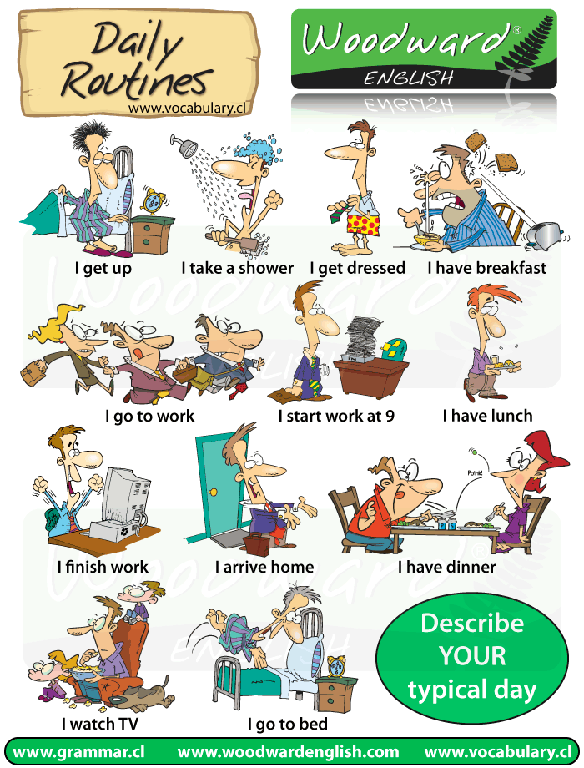
My Daily Routine. Learn the Vocabulary.
2. Read and translate the text. Tell about your Days off
My Days off
I go to school five days a week, so I have two days off — Saturday and Sunday (I'm lucky, because some other pupils have the only one day off). During the week I am very busy, so I like to have a rest on weekend.
I am not an early riser and it is a rare Saturday or Sunday when I get up before 9 o'clock. I enjoy staying in bed, when I don't have to hurry anywhere.
We have late breakfast at 10 and watch TV. Usually we have something tasty: meat salad, fried potatoes, chicken, cake or pie
If the weather is fine, I usually do not stay indoors, I and my dog go outside. Often we go to the park and play there. If the weather is rainy and gloomy, I stay at home and watch TV, listen to the music, read, the books. After dinner we go visit our grandparents or relatives, or just simply take a nap. Sometimes when my friends call me we go roller — blading near the Opera theatre. I like roller — blading very much, I think it is a lot of fun.
In the evenings I like to watch video and music programs. There is a big armchair in my room right beside the lamp with blue shade. If it is cold I like to sit there with cup of coffee and read.
Sometimes I do something special on weekends: go to an art exhibition, to the theatre, to the concert.
I always go to bed late on Sundays, and Monday morning is the nastiest thing through all the week. I like weekends very much, because I can rest and gain some energy for the next week.

Практическая работа №4

Тема 2.2. Здоровье, спорт, правила здорового образа жизни
Цель: совершенствование и развитие навыков устной и письменной речи, навыков чтения и перевода текста профессиональной направленности на английском языке.
1. Read and translate the text
Healthy Way of Life

Today we are going to discuss the problems of the healthy way of life and its advantages.
Before speaking on health problems I'd like to tell you some words about the health services (1) in Russia.
The public health services in Russia embrace (2) the entire population and are financed by the state budget. The private medical services are steadily expanding (3) and constitute (4) a certain part in medicine in Russia. Unfortunately (5), because of economic problems in Russia the government can't afford (6) to make medicine a major item (7) in the state budget. The network of polyclinics, hospitals and dispensaries are not funding (8) enough to modernize the equipment (9) and develop the medical knowledge. But in spite of this there are a lot of talented and highly educated doctors who are devoted to their work and people.
Main emphasis (10) in Russia is laid on prevention (11) or prophylactics. The saying has it that 'an ounce (12) of prevention is worth a pound (13) of cure (14).
There are a lot of problems in Russia but nevertheless medicine is advancing (15) further (16) and is successfully combatting (17) cancer (18), the disease (19) that takes a lot of human lives.
A lot of diseases are preventable (20) through the healthy way of life. A primary public health goal is to educate the general public about how to prevent a lot of diseases. Public health campaigns teach people about the healthy way of life — the value (21) of avoiding (22) smoking, avoiding foods high in (23) cholesterol and fat (24), having a certain amount (25) of exercise and maintaining (26) a healthy body weight (27).
Is there anything more important than health? I rather doubt it. If your body suffers (28) from any disorder (29) your mind suffers with the body, too. You can't be good either at work or at studies. Aches (30) and pains lead to irritation, nervous breakdown (31) and stress. So, the advantages of the healthy way of life are obvious (32). We must remember that laws of the healthy way of life — moderate eating and drinking, regular physical exercises, reasonable hours of work and rest, perfect cleanliness, positive attitude towards people and things around us — lay the foundations (33) for long happy life.
Vocabulary
1. health service - служба здравоохранения
2. embrace - охватывать
3. expand - расширяться
4. constitute - составлять
5. unfortunately - увы
6. afford - разрешить
7. item - пункт
8. fund - финансировать
9. equipment - оснащение
10. emphasis - акцент
11. prevention - профилактика
12. ounce - унция (мера массы)
13. pound - фунт (мера массы)
14. cure - лечение
15. advance - развиваться
16. further - далее
17. combat - бороться
18. cancer - рак
19. disease - болезнь
20. preventable - такие, что можно предотвратить
21. value - ценность, важность
22. avoid - избегать
23. high in - богатые
24. fat - жир
25. amount - количество
26. maintain - сохранять, поддерживать
27. weight - масса
28. suffer - страждати
29. disorder - расстройство, болезнь
30. ache - боль
31. breakdown - удар, расстройство
32. obvious - очевидный
33. foundation - основа
Questions:
1. What are the public health services financed by?
2. What can you say about the private medical services?
3. What is main emphasis in Russia laid on?
4. What do you mean under the notion of healthy way of life?
5. What are the laws of healthy way of life?
2. Read and discuss.
3. Look at the picture and answer the question: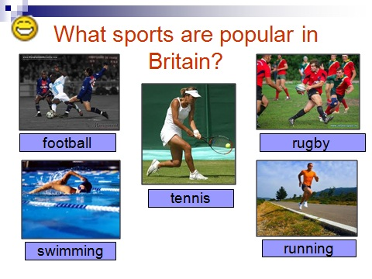

Практическая работа №5

Тема 2.3. Город, деревня, инфраструктура

Цель: совершенствование и развитие навыков устной и письменной речи, навыков чтения и перевода текста профессиональной направленности на английском языке.

1. Active Words and Word Combinations:
as well as – а так же
surface – поверхность
Grand Duke – Великий герцог
significant – значительный
to flow through – течь через
church – церковь
masterpiece of architecture – шедевр архитектуры
scientific – научный
magnificent – великолепный
Tsar-cannon – Царь пушка
Tsar-bell – Царь колокол
2. Read and translate the text
THE CAPITAL OF OUR COUNTRY — MOSCOW
Moscow is the capital of Russia. It is the main economic, political, educational and cultural centre of our country.
In Moscow there are most important state institutions. The Parliament and the Government of Russia are seated here as well as the President.
Moscow is a modern mega polis. With over 10 million people it is one of the most populated in the world. It is also one of the largest with the surface of 880 sq km.
Moscow has a long history. It was founded over 800 years ago by Grand Duke Yury Dolgoruki in 1147. In the beginning it was a rather unimportant town, but year after year it grew into a significant city when, finally, in the 16th century it became the capital of the country. For the period from 1712 to 1917 the capital was moved to St Petersburg.
Moscow is situated on the Moskva river, which flows through the whole city.
The heart of the city, the Kremlin, is the city inside the city. It was built in the 12th century. There are many churches and museums inside the Kremlin as well as various governmental institutions. The Kremlin is a real masterpiece of architecture.
On the territory of the Kremlin there are the Tsar-cannon and the Tsar-bell which have never been actually used.
There are also many museums and galleries in Moscow holding masterpieces of fine arts.
In Moscow, there are many theatres of world level.
Moscow is also a scientific city. Moscow State University is the oldest and the most important in Russia. It was founded by famous Russian scientist Mikhail Lomonosov in 18th century.
Moscow is a magnificent city.
3. Answer the following questions:
What is the capital of Russia?
How large is the population of Moscow?
When Moscow was founded?
By whom Moscow was founded?
When the Kremlin was build?
When Moscow did become the capital of Russia?
What can you see on the territory of the Kremlin?
4. Complete the following sentences:
Moscow is the main …., …., …. and ….. centre of our country.
Moscow is a modern …..
For the period from …. to ….. the capital was moved to …...
Moscow is situated on the ….
The heart of the city is ……
The Kremlin is a real …. of …...
Moscow State University was founded by …. … in …..
5. Choose the correct variant:
1. Moscow was founded over ….. years ago.
а. 700 b. 800 c. 600
2. Moscow is also one of the largest with the surface of …. sq km.
а. 790 b. 870 c. 880
3. Moscow State University is …. in Russia.
а. the most important b. b. more important c. much important
4. The Parliament and the Government of Russia are seated in Moscow as well as the …...
а. Prime-minister b. President c. State Duma
5. The heart of the city, the Kremlin, is the city ….. the city.
а. inside b. outside c. round
6. Moscow State University was founded by famous Russian ….
а. architect b. scientist c. engineer
7. Moscow is one of …. in the world.
such populated b. more populated c. the most populated
6. Say true or false:
In the beginning Moscow was a rather unimportant town.
Moscow stands on the Lena River.
The heart of the city is Moscow State University.
There are many theatres of world level in Moscow.
On the territory of the Kremlin there are many theatres.
7. Speak about your native town or village.

Практическая работа №6

Тема 2.4. Досуг

Цель: совершенствование и развитие навыков устной и письменной речи, навыков чтения и перевода текста профессиональной направленности на английском языке.
1. Read the text and do tasks.
Leisure time

Everybody sometimes has a free time. Somebody prefers only to sleep in their leisure time, but most of us prefer to do a great number of interesting things. It may be reading, various types of sport games, watching TV, listening to music and so on. If we have a few days or a week we prefer to go to the attractive places. Many people think that pupils and students have too much leisure time, but in my opinion, they are wrong. We are very busy. Many pupils have six or seven lessons a day and go to school five or six days a week. Even during weekend we learn our lessons. And we just have no time to go somewhere. Some of us work after school or institute. As for me my free time is devoted to reading. I like to read books about other countries, another times and another worlds. Also I read books about history of our country. Besides reading I like to do physical exercises. I and my school friends often gather after lessons and play basketball, football or other active games. But my favourite hobby is travelling. Usually I travel in summer and often it is a trip to the south, to the warm sea. I think all people must have other occupations besides their basic work, because it extends the boundaries of the familiar world and teaches us something new about people and things.

2. Give Russian equivalents of the following words and word combinations:
Free time, leisure time, to prefer, to do things, weekend, gather, favourite hobby, occupation, boundary, to be devoted to, to the south, familiar world.
3. Answer the questions:
1) What do people prefer to do in their free time?
2) Do pupils and students have much leisure time?
3) Why are they very busy?
4) How do yоu spend your free time?
4. Match the words in the columns.
1. leisure
2. spare time
3. go out
4. stay-at-home
5. favourite occupation
6. hobby
7. entertain
8. entertainment
9. enjoy oneself (have a good time)
10. enjoy smth
a. свободное время
b. хобби
c. развлекать
d. получить удовольствие от…
e. досуг
f. любимое занятие
g. развлечение, увеселение, представление
h. хорошо провести время
i. домосед
j. бывать в обществе, проводить время вне дома
5. Make up your own sentences :
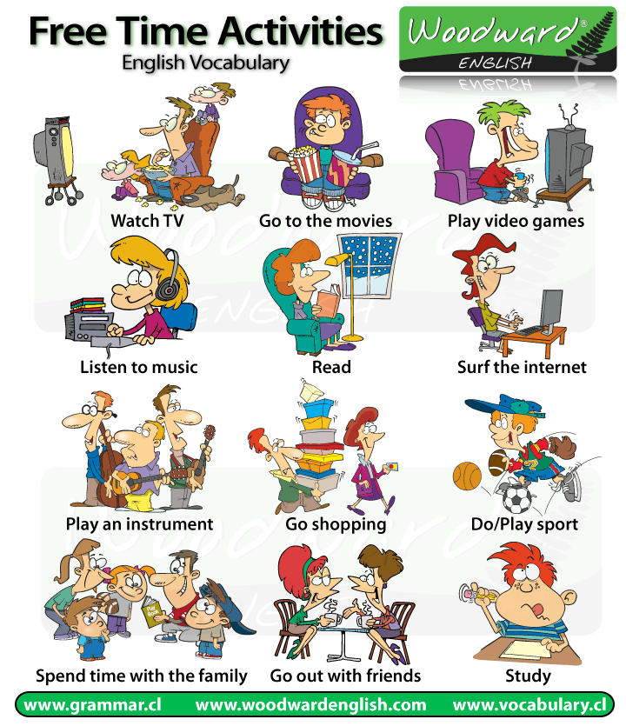
Практическая работа №7

Тема 2.5. Новости, средства массовой информации

Цель: совершенствование и развитие навыков устной и письменной речи, навыков чтения и перевода текста профессиональной направленности на английском языке.

1. Active Words and Word Combinations:
mass media
to meet eminent people
to shape public opinion
means of communication
to influence audience advertising
public relations
to play a crucial role in smth
forming public opinion
to be made up of smth
newsgathering
to provide news output
to force attention to smth
to build up a public image
capacity to act autonomously
impartial
средства массовой информации
встречаться с выдающимися людьми
формировать общественное мнение
средства связи
реклама оказывает влияние на аудиторию
связи с общественностью
играть решающую роль в чем-либо
формировать общественное мнение
состоять из чего-либо
сбор новостей
обеспечивать выпуск новостей
привлекать внимание к чему-либо
создавать имидж
способность к самостоятельным действиям
объективный, беспристрастный
2. Read the text, translate and do the tasks:
MASS MEDIA
To live in the modern world is impossible without expanding your knowledge in all spheres. There are several ways of communicating the world of individuals-mass media, books, travelling, museums, meeting eminent people. Of all the existing ways, there are two which are the easiest, those are mass media and travelling. It’s not a secret the different media are used to communicate news and entertainment. They include print media and electronic media.
Mass media play an important role in our life. They are usually defined by encyclopedias as any of the means of communication, such as radio, television, newspapers, magazines, etc. that reach and influence a very large audience, at least as large as the whole population of a nation.
I believe mass media are so influential because they can be used for various purposes: popularization, education, entertainment etc.
Mass media play a crucial role in forming public opinion. But how much do the media influence the modern society? Early critiques suggested that the media destroys the individual’s capacity to act autonomously. Later studies, however, suggest a more complex interaction between the media and society. People actively interpret and evaluate the media and the information it provides.
3. Fill in the blanks. The first letter of each missing word has been given:
The mass media refers to the people and organizations that provide news and i……….(1) for the public. Until recently these were mainly n………..(2), t…….(3), and r………(4). Today, computers play a very big part. The I………..(5) is a computer system that allows millions of people around the world to receive and exchange information about almost everything. Ordinary post has been taken over by e……….(6) which stands for e……..(7) mail because it is sent m…………(8) to each other quickly and cheaply. Ordinary p………..(9) is now referred to as “snail-mail” and one wonders if the p……..(10) is a job in danger of extinction!
4. Translate into English:
Средства массовой информации - это средства коммуникации, такие как радио, телевидение, газеты, журналы, которые создают очень большую аудиторию.
Средства массовой информации играют ведущую роль в формировании общественного мнения.
Они доносят до людей информацию о мире.
Они также воспроизводят созданный современным обществом его собственный имидж.
Они создают аудиторию, которая поддерживает их в финансовом отношении.
Make your own sentences using topic vocabulary.

Практическая работа №8

Тема 2.6. Природа и человек (климат, погода, экология)

Цель: совершенствование и развитие навыков устной и письменной речи, навыков чтения и перевода текста профессиональной направленности на английском языке.

1. Read, translate and learn this poem.
Whenever the weather is cold.
Whenever the weather is hot.
We'll weather the weather,
whatever the weather,
whether we like it or not.
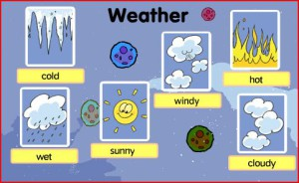
2. Read and translate the text.
Seasons
The year is divided into four seasons: spring, summer, autumn, and winter.
In spring nature awakens from her long winter sleep. The trees are filled with new life, the earth is warmed by the rays of the sun, and the weather gets gradually milder. The fields and meadows are covered with fresh green grass. The sky is blue and cloudless. At night millions of stars shine in the darkness.
When summer comes the weather gets warmer still and sometimes it’s very hot. It’s the farmer’s busy season: - he works in his field from morning till night. The grass must be cut and the hay must be made, while the dry weather lasts. Sometimes the skies are overcast with heavy clouds. There are storms with thunder, lightning and hail.
Autumn brings with it the harvest-time when crops are gathered in and the fruit is picked in the orchards. The days get shorter and the nights longer. The woods turn yellow and brown, leaves begin to fall from the trees, and the ground is covered with them. The skies are grey and very often it rains.
When winter comes, we’re obliged to spend more time indoors because out-of-doors it’s cold. We may get fog, sleet and frost. Ponds, lakes, rivers and streams are frozen, and the roads are sometimes covered with slippery ice or deep snow. The trees are bare. Bitter north winds have stripped them of all their leaves.
(from “The London Linguaphone Course”)
Vocabulary:
earth – земля
gradually – постепенно
darkness – темнота, потемки
hay – сено
dry – сухой
crop – урожай, жатва
orchard – фруктовый сад
to turn yellow – становиться желтым
to oblige – обязывать, принуждать, вынуждать
pond – пруд
stream – ручей
bare – голый, обнаженный
to strip – сдирать, снимать, лишать
3. Retell the text.

Практическая работа №9

Тема 2.7. Образование в России и за рубежом, среднее профессиональное образование
Цель: совершенствование и развитие навыков устной и письменной речи, навыков чтения и перевода текста профессиональной направленности на английском языке.

1. Read the text and do the tasks.

Education in Britain
In England and Wales compulsory school begins at the age of five, but before that age children can go to a nursery school, also called play school. School is compulsory till the children are 16 years old.
In Primary School and First School children learn to read and write and the basis of arithmetic. In the higher classes of Primary School (or in Middle School) children learn geography, history, religion and, in some schools, a foreign language. Then children go to the Secondary School.
When students are 16 years old they may take an exam in various subjects in order to have a qualification. These qualifications can be either G.C.S.E. (General Certificate of Secondary Education) or "O level" (Ordinary level). After that students can either leave school and start working or continue their studies in the same school as before. If they continue, when they are 18, they have to take further examinations which are necessary for getting into university or college.
Some parents choose private schools for their children. They are very expensive but considered to provide a better education and good job opportunities.
In England there are 47 universities, including the Open University which teaches via TV and radio, about 400 colleges and institutes of higher education. The oldest universities in England are Oxford and Cambridge. Generally, universities award two kinds of degrees: the Bachelor's degree and the Master's degree.
2.Give Russian equivalents of the following words and word combinations:
Compulsory, age, nursery school, foreign language, secondary school, exam, subject, Certificate, "O level" (Ordinary level), university, private school, expensive, education, higher education, opportunity, bachelor, master.
3. Answer the questions:
1. When does compulsory school begin?
2. How long does a child stay in compulsory school?
3. What subjects do children learn in Primary School?
4. What kind of exam do students have to take when they are 16?
5. Do students have to leave school at the age of 16 or to continue their studies?
6. How do private schools differ from the regular ones?
7. How many universities are there in England?
8. What is the Open University?
9. What kinds of degrees do universities award?

Практическая работа №10

Тема 2.8. Культурные и национальные традиции, краеведение, обычаи и праздники

Цель: совершенствование и развитие навыков устной и письменной речи, навыков чтения и перевода текста профессиональной направленности на английском языке.
1. Read and translate. Make up a cluster using this information.
Some special days in Britain
Saint Valentine’s Day 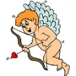 Cupid
14th February, when traditionally people send a valentine (=special card) to someone they love, often without saying who the card is from. They may also send flowers or other presents as a sign of love.
a daffodil Saint David’s Day a leek
Saint David, the patron saint of Wales, is celebrated on 1st March each year. This is the Welsh national holiday. Many Welsh people wear one or both of the national emblems of Wales. Boys usually wear leeks whilst girls wear daffodils.
Saint Patrick’s Day a shamrock
The patron saint of Ireland, who helped to spread the Christian religion there and who people think got rid of snakes in Ireland. St Patrick's Day, 17th March, is celebrated in Ireland where people drink Irish beer and often wear green clothes.

Easter an Еaster Bunny
A Christian holiday in March or April when Christians remember the death of Christ and his return to life. People give each other chocolate eggs. Children believe the Easter bunny brings the chocolate eggs.
Saint George’s Day St. George's Cross
This is the patron saint of England. The national holiday is celebrated on 23rd April. This day is not celebrated as much in England as other National Days are around the world. People wear a rose or fly the St. George's Cross flag
Hallowe'en a pumpkin
The night of 31st October, which is now celebrated by children, who dress
in costumes and go from house to house asking for sweets. This is called trick-or-treating. In the past, people believed the souls of dead people appeared on Hallowe'en.
Guy Fawkes Night fireworks

People celebrate this night on the 5th November. Guy Fawkes tried to blow up the Housesof Parliament in 1605. He didn't succeed. Now people celebrate this with fireworks, burningdolls and a song: remember, remeber the fifth of Novemer!
Saint Anderw’s Day 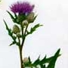 a thistle
He is the patron saint of Scotland and St Andrew's Day, 30th November,
is celebrated as the Scottish national day. They wear a thistle on this
special day.
Сhristmas Father Christmas
Christmas Eve is celebrated on the 24th December. Children leave socks and hope
Father Christmas will bring some presents. Christmas Day, 25th December is a family day. People usually have dinner and sit around the Christmas tree.
Boxing Day a box
This name goes back to the tradition that richer people gave the poor a box,
filled with all kinds of food. Even today some companies give their workers
a kind of Cristmas box. This bank holiday is celebrated on 26th December.
New Year’s Eve a party

On 31st December, the last day of the year, many people go to parties. They also make some New Year's resolutions (a decision to do something better or to stop doing something bad in the new year).
2. Read the text. Rearrange the paragraphs from the Russian variant into right order.
Holidays in Russia
A men needs rest after hard work. Very often we are eagerly looking forward to weekends and holidays to enjoy ourselves.
The word "holiday" comes from the words "holy day". Holidays were first religion festivals. Now many holidays have nothing to do with religion. Almost every country has holidays honoring important events in its history.
Some holidays come on the same date of the same month, for instance, New Year's Day or Christmas. But some do not. Some, such as Easter, are movable holidays.
New Year's Day is very popular all over the world. It is my favorite holiday. We usually get together, we like celebrate this holiday at home.
We celebrate the first day of Christmas on the 7th of January. On the 6th of January people tidy the whole house, cook much tasty food because the day after we must not work, we must have a rest. On this day we have a sacred supper. It begins when the first star lights up. As the legend says, this star announced the birth of the God's Son. We celebrate Christmas for two days. In the evening a group of boys comes. They sing songs. By these songs they congratulate on holiday, wish good crops, long life, no illness and so on. It is interesting to know that only boys must congratulate.
Women's Day is on the 8th of March.
Then on the 1st of May goes next holiday the Day of Labor.
Another religious holiday is Easter. It is movable. It is usually the first Sunday after the first fullmoon after the beginning of spring. In Russia we have special attributes of Easter: Easter eggs, and Easter "paska" that are baked according to the special recipe. It is a very nice spring holiday.
Victory Day is on the 9th of May. It is a sacred holiday for every Russian citizen. We are thankful to our grandfathers for the victory in the World War II.
Праздники в России
1. Слово «праздник» происходит от слов «священный день». Первые праздники были религиозными. Сегодня же многие праздники не имеют ничего общего с религией. Почти в каждой стране есть праздники, которые отмечают важные события в ее истории.
2. Мы празднуем Рождество 7 января. 6 января убирают дом, готовят много вкусных блюд потому что на следующий день работать нельзя, следует отдыхать. В этот день — Святой вечер (Сочельник). Он начинается с первой звездой, ведь легенда гласит, что эта звезда означает рождение Сына Божьего. Мы празднуем Рождество два дня. Вечером мальчики приходят щедровать. Они поют песни. Этими песнями они всех поздравляют с праздником, желают хорошего урожая, долгой жизни, здоровья. Интересно, что щедровать могут только мальчики.
3. Некоторые праздники имеют фиксированную дату, например, Новый год или Рождество, другие нет. Некоторые, например, Пасха, — переходные праздники.
4. Новый Год очень популярен во всем мире. Это и мой любимый праздник. Мы обычно собираемся все вместе. Мы любим отмечать этот праздник дома.
5. 9 мая — День Победы. Это священный праздник для каждого российского гражданина. Мы благодарны нашим дедам за победу во второй мировой войне
6. 8-го марта мы празднуем Женский День.
7. Потом 1 мая идет следующий праздник — День Труда.
8. Другой религиозный праздник — Пасха. У этого праздника нет фиксированной даты, она меняется. В России есть специальные атрибуты Пасхи: пасхальные яйца и пасхальные куличи («пасхи»). Пасха — очень хороший весенний праздник.
9. Человеку нужно отдыхать после работы. Очень часто мы с нетерпением ждем выходных и празднbков, чтобы как следует отдохнуть.

Практическая работа №11

Тема 2.9. Общественная жизнь (повседневное поведение,
профессиональные навыки и умения)

Цель: совершенствование и развитие навыков устной и письменной речи, навыков чтения и перевода текста профессиональной направленности на английском языке.

1. Read and translate the text.
Student’s Life
It's great to be a student. Many colleges and universities offer great opportunities for studying and for social life. Some students even choose to study abroad.
There are several reasons why student life is exciting. First of all, students learn what they need for their future profession. It's even better if the student really enjoys the direction he or she chose. Secondly, being a student doesn't mean to work and study all the time. They get plenty of free time for their hobbies and favourite pastimes. Thirdly, students' social life is very interesting.
When students decide to study in foreign colleges, it's also rather exciting. They get to meet lots of new people from other countries. They can practice and improve their language skills. To study at a college students usually have to pay additional fee.
College life is amazing in many ways. First of all, there are many interesting lections and training sessions. Secondly, students find all sorts of entertainment there. For example, the ones who like sport join the local sports teams. For many people college years are the best in life. Almost everyone has good memories of student life. It is even more interesting to be a student if you live in a dormitory. After the sessions they can play the guitar and sing songs. The ones, who like dancing, go to local discos. Others get together simply to chat and discuss the topics they've learned. Student life is never boring. It is always full of excitement and interesting experiences.
2. Give Russian equivalents of the following words and word combinations:
opportunity for studying, social life, abroad, future profession, to enjoy, free time, hobby and pastime, practice and improve language skills, fee, lection and training session, dormitory, to chat, boring, excitement.
3. Give English equivalents of the following words and word combinations:
университет, причина, направление, любимый, колледж, страна, платить, развлечение, память, играть на гитаре, петь песню, местный, обсуждать, опыт.
Практическая работа №12
Тема 2.10. Научно-технический прогресс
Цель: совершенствование и развитие навыков устной и письменной речи, навыков чтения и перевода текста профессиональной направленности на английском языке.
1. Learn English technical alphabet.
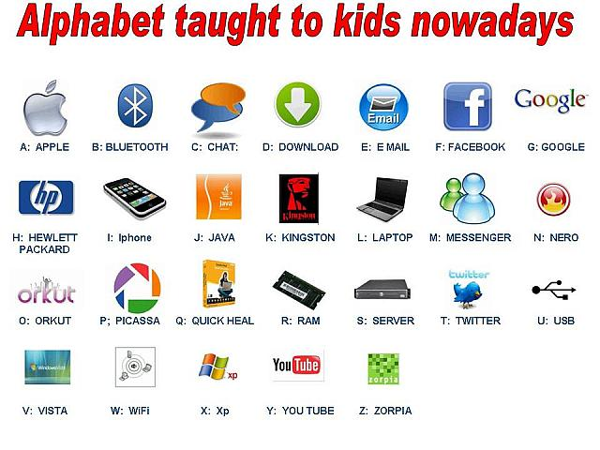
2. Read and translate the text.
The Impact of Modern Technology on Our Lives
People in contemporary world can hardly imagine their lives without machines. Every day either a new gadget is invented or an old one is improved. Different people appreciate new inventions differently. Some suppose that sophisticated gadgets are really useful and necessary, while others find them absolutely awful as they influence people badly. As for me, I am pretty sure that gadgets make people`s lives easier.
Firstly, they do all kinds of dirty and hard work, as cleaning. Secondly, devices can save a lot of time as well as storage space. For instance, a computer disk can contain the same amount of information as several thick books. So, machines help people in different spheres.
However, opponents of this point of view are definitely sure that gadgets affect people negatively. People are reluctant to work due to the influence of machines. People become lazy and disorganized. They just expect their latest gadgets to do everything instead of them. Moreover, according to scientists, a great number of widespread devices produce radiation that can cause serious health problems. Furthermore, more and more people are becoming addicted to their modern gadgets, for instance computers, TVs or mobile phones. So, they neglect their home obligations, work or school and spend all their spare time in front of a laptop screen or a TV-set.
In conclusion I firmly believe that in spite of all drawbacks gadgets have their benefits. They save people`s time and let them enjoy life.
3. Give Russian equivalents of the following words and word combinations:
contemporary world, new gadget is invented, invention, useful and necessary, influence people badly, storage, computer disk, affect people negatively, scientist, radiation, cause serious health problems, drawback, benefit, laptop screen.
4. Fill in the blanks with the following words:
easier, radiation, drawbacks, machines, people
1. Modern people cannot live without…. . 2. Gadgets make our lives… . 3. Some people think that gadgets affect … negatively. 4. Scientists say that … can cause serious health problems. 5. In spite of all… gadgets have their benefits.
5. Read the text and make up ten questions on the text.
Mobile phones
At present mobile phones have become very important in our everyday lives and the majority of people can hardly imagine themselves without cell phones. Is it just a tribute to fashion or a necessity of a modern person?
It isn’t a secret that today many people feel quite helpless if they have left their mobile phones at home. First of all cell phones give us an opportunity to keep in touch with people in any place and in any time (it’s especially important for businesspeople). Besides, modern mobile phones are multi-function: they provide access to the Internet, have various games, cameras, memory sticks, etc.
Nevertheless we can’t deny that mobile phones provoke a range of problems. People have started to see each other less frequently. Mobile communication requires quite a lot of money and people have to control the amount of money on their accounts constantly otherwise at the most inappropriate moment they won’t be able to phone the people they need. But the greatest disadvantage of cell phones is certainly their harmful influence on people’s health.
In my opinion at the present time mobile phones are an integral part of life of any person and we can’t stop it. I personally need it every day for my work and to keep in touch with my friends and relatives, though I’m aware of its deleterious influence on my health. But I try to avoid idle talks on the phone to reduce the influence of harmful radio waves. I try to find the happy mean.

Практическая работа №13

Тема 2.11. Профессии, карьера.

Цель: совершенствование и развитие навыков устной и письменной речи, навыков чтения и перевода текста профессиональной направленности на английском языке.

1. Read and learn the names of profession in English.

Find out the transcription for them.
Мы каждый день сталкиваемся с водителями (drivers), продавцами (salesmen/shop-assistants), служащими (clerks). В школе ждут учителя (teachers), а в институте преподаватели (professors). Лечат врачи (doctors), например, стоматологи (dentists) и медсёстры (nurses). В театре мы наблюдаем за игрой актёров (actor/actress), а на концертах слушаем музыкантов (musicians), певцов (singers) или оцениваем выступление танцоров (dancers). Наши дома проектируют архитекторы (architects), возводят строители (builders) и плотники (carpenters), а обслуживают инженеры (engineers), электрики (electricians) и сантехники (plumbers). В салонах красоты обслуживают парикмахеры (hair-dressers). Наши права защищают полицейские (policemen) и юристы (lawyers). В ресторане обслуживают официанты (waiter/waitress), предлагая блюда от шеф-повара (cook, chef). Прозанимавшись с репетитором (tutor), посоветовавшись со спецом (expert/specialist), мы нанимаемся к начальнику (boss/chief).
2. Fill in the blanks (am- is -are) and translate the sentences:
1. My sister … a nurse.
2. You … a baker.
3. They … engineers.
4. I … a fireman.
5. My parents … doctors.
6. Tom and John … pilots.
7. He … a good farmer.
8. We … students.
9. His father … a policeman.
10. I … a clown.
3. Guess the professions:
a farmer, a programmer, a vet, a teacher, a photographer, an engineer, an astronaut, a nurse, a pilot, a clown
Who works in a field?
Who works with computers?
Who helps sick animals?
Who helps children to learn?
Who takes pictures of famous people?
Who makes new cars?
Who flies in a spaceship?
Who helps doctors?
Who flies in airplanes?
Who can play tricks?
IV. Match the words and the sentence:
1. a teacher 2. a doctor 3. a policeman 4. a clown
5. a postman 6. a dancer 7. a fireman 8. a baker
9. a dentist 10. a pupil
1. He bakes bread.
2. He works in a circus.
3. He takes care of our teeth.
4. He fights fires.
5. She studies at school.
6. He delivers letters.
7. She gives pupils homework.
8. He helps sick people.
9. He protects people.
10. She works in a theatre
Практическая работа №14

Тема 2.12. Отдых, каникулы, отпуск. Туризм.

Цель: совершенствование и развитие навыков устной и письменной речи, навыков чтения и перевода текста профессиональной направленности на английском языке.

1. Active vocabulary:
overseas — заграница
majority — большинство
to seem — казаться
to book — заказывать
resorts— курорт
straight — прямо
a tropical beach — тропический пляж
to breathe — дышать
to hitclbhike — путешествовать автостопом
advantage — преимущество
to explore — исследовать
to climb — взбираться, карабкаться
restriction — ограничение
indeed — действительно
curious — любопытный
inquisitive — любознательный
leisure — досуг
jet-air liner — реактивный самолет
security — безопасность
variety — разнообразие
city-dweller — городской житель
to take pictures — фотографировать
castle — крепость, замок
waterfall — водопад
to remind — напоминать
picturesque — живописный
to broaden one's mind — расширить кругозор
take part in negotiations — принимать участие в переговорах
exhibition — выставка
in order to — для того чтобы
to push the goods — рекламировать товары
achievement — достижение
successful — успешный
advantages and disadvantages — преимущества и недостатки
according to — согласно
2. Read the text and answer the questions:
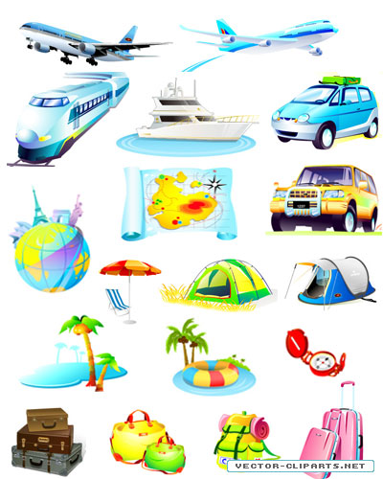
Tourism

Twenty years ago not many people travelled overseas for their holidays. The majority of people stayed to have holidays in their country. Today the situation is different and the world seems much smaller.
It is possible to book a holiday to a seaside resort on the other side of the world. Staying at home, you can book it through the Internet or by phone. The plane takes you straight there and within some hours of leaving your country, you can be on a tropical beach, breathing a super clean air and swimming in crystal warm water of tropical sea.
We can travel by car, by train or plane, if we have got a long distance tour. Some young people prefer walking or hitch-hike travelling, when you travel, paying nearly nothing. You get new friends, lots of fun and have no idea where you will be tomorrow. It has great advantages for the tourists, who want to get the most out of exploring the world and give more back to the people and places visited. If you like mountains, you could climb any mountains around the globe and there is only one restriction. It is money. If you like travelling, you have got to have some money, because it is not a cheap hobby indeed. The economy of some countries is mainly based on tourism industry. Modern tourism has become a highly developed industry, because any human being is curious and inquisitive, we like leisure, visit other places. That is why tourism prospers.
People travel from the very beginning of their civilization. Thousands years ago all people were nomads and collectors. They roamed all their lives looking for food and better life. This way human beings populated the whole planet Earth. So, travelling and visiting other places are the part of our consciousness. That is why tourism and travelling are so popular.
Nowadays tourism has become a highly developed business. There are trains, cars and air jet liners, buses, ships that provide us with comfortable and secure travelling.
If we travel for pleasure, by all means one would like to enjoy picturesque places they are passing through, one would like seeing the places of interest, enjoying the sightseeing of the cities, towns and countries.
Nowadays people travel not only for pleasure but also on business. People have to go to other countries for taking part in different negotiations, for signing some very important documents, for participating in different exhibitions, in order to exhibit the goods of own firm or company. Travelling on business helps people to get more information about achievements of other companies, which will help making own business more successful.
There are a lot of means of travelling: travelling by ship, by plane, by car, walking. It depends on a person to decide which means of travelling one would prefer.
Questions:
1. Did the majority of people leave their country to spend holidays twenty years ago?
2. Can we book a holiday to a seaside resort on the other side of the world today?
3. Is it possible to book a holiday to a seaside resort on the other side of the world from home?
4. What means of travelling do you know?
5. What countries depend mainly on tourism?
6. Why does tourism prosper?
7. Where do people like going on vacation?
8. What is the most interesting means of travelling for you? Why?
9. Why do most travellers carry a camera with them?
10. What does travelling give us?
11. How does travelling on business help you?
12. What are the means of travelling?

Практическая работа №15

Тема 2.13. Искусство и развлечения.

Цель: совершенствование и развитие навыков устной и письменной речи, навыков чтения и перевода текста профессиональной направленности на английском языке.
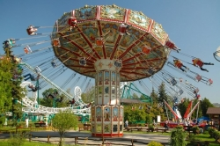
Entertainments

I am fond of good books and good music, and when I have some time to spare, I like to go to the theatre or a concert. There are more than a dozen very good orchestras in Britain and some of them are world famous. Orchestras in Britain have no concert

halls of their own, but play in halls rented from local authorities or private companies.
There are 2 big concert halls in London. The Old Royal Albert Hall and the New Royal Festival Hall, which is one of the most modern concert halls in the world. Theatrical performances are given by theatre companies. There are about 200 professional theatres in Britain. Like orchestras, the theatre companies usually play in rented theatres, but there are several theatres which have their own homes. The center of the art life is London. London is also the main center of opera and ballet. In Britain the choice of films is limited to young people.
Films are placed in one of three categories in Britain. "U" - suitable for everybody, "A" - more suitable for adults, "X" - suitable only for adults. A person under 16 years of age may see an "A" film only in company of an adult. Only person over 16 years of age may see "X" films. Those, who prefer to stay at home may spend their free time, watching TV, listening to the radio. They have many TV and radio programs to choose from. As for me, I am a great cinema-goer. I like the cinema tremendously. I see all the best films that are on. I prefer features films, though I enjoy documentaries almost as much to say nothing of animated cartoons films, news-reels or popular science films.
I usually go to the cinema for the morning or day shows. If I want to go to an evening show I book tickets beforehand. I like to come to the cinema a couple of minutes before the movie starts. If there is a long time to wait I can always look at the portraits of film stars hanging on the walls of the foyer, or listen to a little concert that is usually given for the spectators. It is a good idea, that those who are late are not allowed to enter the hall until the news-reel is over.
I hate being disturbed when a film is on. If I like a movie very much I go to see it a second time and besides I see many of the movies televised. I often read the paper "Film Week" to know which films have been released and which ones are being shot. I know all the famous script writers, producers and cameramen.

Практическая работа №16

Тема 2.14. Государственное устройство, правовые институты.

Цель: совершенствование и развитие навыков устной и письменной речи, навыков чтения и перевода текста профессиональной направленности на английском языке.

1. Listen and read the text and answer the questions after it:

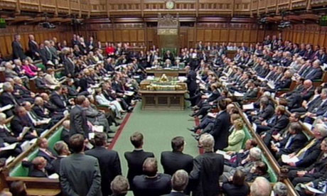
The Political System of Great Britain

Great Britain is a constitutional monarchy. The head of state is Queen Elizabeth II. The queen reigns, but does not rule.
The legislative power in the country is exercised by Parliament. Parliament makes the laws of Great Britain. It consists of the queen, the House of Commons, and the House of Lords.
The House of Commons is Britain’s real governing body. It has 650 members, elected by the people. Members of the House of Commons have no fixed terms. They are chosen in a general election, which must be held at least every five years. But an election may be called anytime, and many Parliaments do not last five years. Almost all British citizens 18 years old or older may vote.
The House of Lords is the upper house of Parliament. It was once the stronger house, but today has little power. It can delay – but never defeat – any bill. The House of Lords has about 1170 members. The people do not elect them. The House of Lords is composed of hereditary and life peers and peeresses. Their right to sit in the House passes, with their title, usually to their oldest sons.
The prime minister is usually the leader of the political party that has the most seats in the House of Commons. The monarch appoints the prime minister after each general election. The monarch asks the prime minister to form a Government. The prime minister selects about 100 ministers. From them, he picks a special group to make up the Cabinet.
The Cabinet usually consists of about 20 ministers. The ministers of the more important departments, such as the Foreign and Commonwealth Office, and the Home Office, are named to every Cabinet.
The government draws up most bills and introduces them in Parliament. The queen must approve all bills passed by Parliament before they can become laws. Although the queen may reject a bill, no monarch has since the 1700’s.
Law courts of Great Britain operate under three separate legal system – one for England and Wales, one for Northern Ireland, and one for Scotland. In all three systems, the House of Lords is the highest court of appeal in civil cases. It is also the highest court of appeal in criminal cases, except in Scotland. The queen appoints all British judges on the advice of the government.
Political parties are necessary to British’s system of government. The chief political parties in Britain today are the Conservative Party and the Labour Party. The Conservative Party developed from the Tories, and has been supported by wealthy people as well as professional people and farmers. The Labour Party has been supported by skilled and unskilled workers, especially union members.
The Constitution of Great Britain is not one document. Much of it is not even in writing, and so the country is said to have an unwritten constitution. Some of the written parts of Britain’s Constitution come from laws passed by Parliament. Some – from such old documents as Magna Carta, which limited the king’s power. Other written parts come from common law, a body of laws based on people’s customs and beliefs, and supported in the courts.
1. Is Great Britain a monarchy?
2. Who is the head of state in Great Britain?
3. What body is the legislative power in Great Britain exercised by?
4. What does the British Parliament consist of?
5. How many members has the House of Commons?
6. Has the House of Lords strong power?
7. Are the members of the House of Lords elected?
8. Does the monarch or the prime minister form the government?
9. How many ministers are there in the Cabinet?
10. What body draws up bills?
11. What body is the highest court of appeal?
12. What political parties are there in Great Britain today?
2. Look at the pictures and speak about the political systems of Russia and Great Britain.

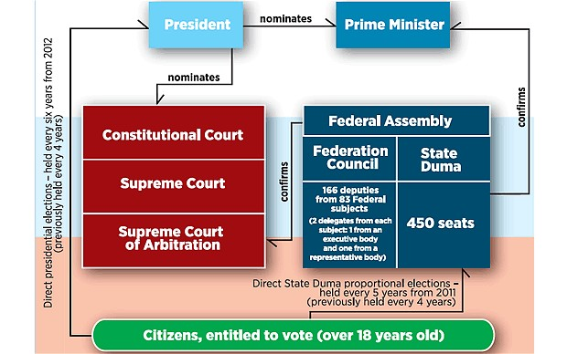
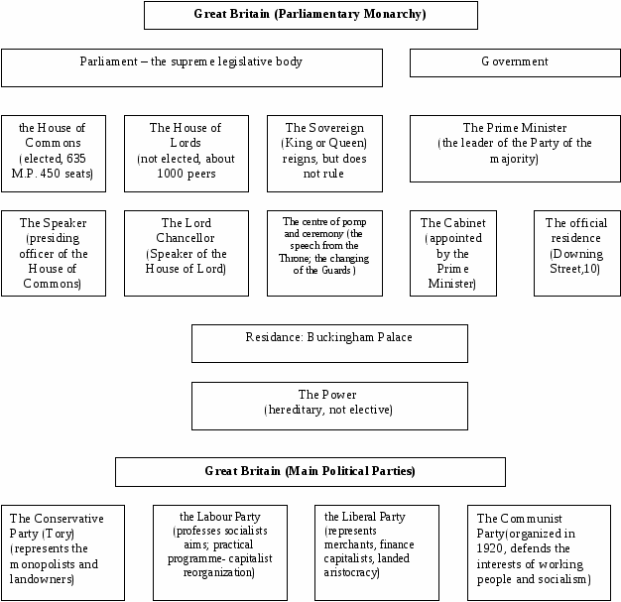
Практическая работа №17

Тема 3.1. Документы (письма, контракты)

Цель: совершенствование и развитие навыков устной и письменной речи, навыков чтения и перевода текста профессиональной направленности на английском языке.

1. Study it and do exercises.
Образец написания личного письма
1) 2 Victoria Street
Oxford
OX2 006

January 15th
3) Dear Sally,
4) Thank you for your lovely birthday card, I have not written sooner as I
wanted to invite you round and would never find a suitable time.
5) We are having a small party next Friday night to celebrate Tony’s return From Canada, and we would be very happy if you and Simon could join us, around 8 p.m. Do come if you can.
Looking forward to seeing you.
7) Yours, 8) Margery
2. Fill the blanks with the following sentences:
a) I am writing with reference to your advertisement in today’s paper concerning possible work with English-speaking tourists
b) I look forward to hearing from you in the near future
c) Before I can consider the job I need to know what the hours of work and pay would be
d) I can communicate well and fairly fluently
Dear Sir/Madam,
1_______. I am very interested in doing this kind of job and will be available from the beginning of the next month. I need to know exactly when the job would start. I should say that my level of English is god. 2_______. I have spent time on holiday in Britain and really enjoy meeting people from other countries. I have always been interested in the history and culture of my local area. 3_______. I would like to know more about what “be responsible for the general welfare of your group” means and what they could involve. I am afraid that I will only be available for interview in the evening (due to present work commitments). 4_______.
Yours faithfully,
Ingrid Nelson
3. You are going to receive card of American Bank.
Fill in this Application Form.
Application Form
First name
Surname
Address
Tel
E-mail
Date and place of birth
Citizenship
Marital status
Occupation
Hobby
Signature
Date
4. You are going to the International Camp. Fill in the following Application Form.
Application Form
Surname ( in BLOCK CAPITALS) ____________________________________________
First name_______________________________________________________________
Age ____________________________________________________________________
Sex M□ F □
Date and place of birth______________________________________________________
Citizenship_______________________________________________________________
Сollege__________________________________________________________________
Foreign languages __________________________________________________________
Hobby___________________________________________________________________
Address___________________________________________________________________ Telephone________________________________________________________________
Signature_________________________ Date___________________________________

Практическая работа №18

Тема 3.2. Планирование времени (рабочий день)

Цель: совершенствование и развитие навыков устной и письменной речи, навыков чтения и перевода текста профессиональной направленности на английском языке.

1. Read and translate this text.
My Daily Routine
Usually I get up at seven o’clock in the morning. I put on my dressing-gown, go into the bathroom and turn on the bath taps. Good health is better than wealth, so I do my morning exercises. I get breakfast at seven-thirty and listen to the news over the radio.
I like to begin the day well, so my breakfast is always a good one. For breakfast I usually have hard-boiled eggs or an omelette, bread and butter, tea or coffee. I read my newspaper with my last cup of coffee before I leave home.
Then I say "Good-bye" to my mother, take my bag and go to the college. I don't live far from my college, so it doesn't take me long to get there. The lessons start at nine. Each lesson lasts for 45 minutes. The classes are over at two o'clock.
I come back home, have dinner, wash up and go shopping. I buy foodstuffs for the family. Coming back I begin to clean the house and get the vegetables ready for supper. We have supper at seven. I do my homework for the next day. It usually takes me several hours to prepare well for the lessons.
In the evening I always try to spend at least an hour at the piano. As a rule my parents and I sit and talk, watch a film on TV, read newspapers and magazines. Sometimes we go to the cinema or to the theatre. Once or twice a month I visit exhibitions in my home town.
I go to bed at about eleven o'clock, but my parents like to sit up late and write letters or read.
Vocabulary:
dressing-gown — халат
tap — кран
to turn on — включать
health — здоровье
hard-boiled — сваренный вкрутую
to get... ready for... — готовить, подготавливать к...
at least — по крайней мере
to sit up — не ложиться спать
to go to bed — ложиться спать
2. Answer the following questions:
1. When do you usually get up?
2. Why do you do your morning exercises?
3. What do you have for breakfast?
4. How long does each lesson last?
5. When do you begin to clean the house?
6. What do you do in the evening?
7. Where do you go sometimes?
8. When do you go to bed?
3. Read the dialogue and dramatize it.
A. Olya! Hi!
B. Hello, Katya!
A. Monday’s a real bind/grind, isn’t it?
B. Sure it is! It’s always really hard to come back on a Monday, after the weekend. Especially now we’ve got lessons on Saturday, too.
А. Can’t beat Sundays! Have a lie in, no rushing off anywhere. And my mum always tries to arrange something special. Bakes a cake, makes us something really nice.
B. Fab! I love nice food. Then I watch some TV – there’s a good programme on Art. I really love things like “History of a Pointing” or “Russian Museum”.
A. So do I. It’s really nice just sitting in front of the box, when the weather’s bad.
B. Right. But when it’s nice, it’s such a shame to stay indoors. After all, we’re inside all week with no fresh air. So you really need to get out when it’s fine on Sunday.
A. Last Sunday we decided to do go back and relive our childhood, so we went to the Zoo. It was really great.
B. Oh, I haven’t been for ages. I must go sometime.
A. Do you like the cinema? Maybe we can go one evening – there’s a first night this Sunday – Oleg Menshikov’s in the film.
B. I really prefer the theatre. But if you think this film’s worth watching. I’ll go.
A. I’ll phone you. OK?
B. Fine. But you knew, sometimes I just enjoy staying at home with my family.
A. Nothing beats your day off. Anything’s better than Monday.
4. Prepare your own topic about your Daily Routine.

Практическая работа №19

Тема 3.3. Условия проживания, система социальной помощи.

Цель: совершенствование и развитие навыков устной и письменной речи, навыков чтения и перевода текста профессиональной направленности на английском языке.
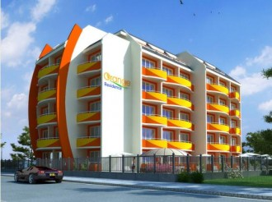
1. Read and translate the text.

My Home

First of all I should say that I like my house. I agree with the conclusion that any home reflects the personality of his owner and his habits. Clothes you wear or food you buy and eat are reflection as well. So, we can make up a conclusion about a man looking at his house.
I prefer a comfortable life. I think it is necessary to have all modern conveniences. It makes life easier, more enjoyable and pleasant. But the atmosphere is more important than conditions. I’d like to say some words about my flat.
We are a family of three. We live in a new five-storied block of flats. Our flat is on the 5th floor. It is very comfortable. When you enter the flat you can see a small entrance hall. On the right side you can see a closet. Then there is a corridor which is much larger than hall. On the left there is a bathroom and a lavatory in the corridor. On the opposite side you are welcome to my room. Walking along the corridor you will come to the kitchen. It is our dining and living room. My parent’s bedroom is on the left from the kitchen. We have all modern conveniences such as cold and hot running water, gas, electricity, central heating, a telephone and a chute.
Our living room is the largest one. It overlooks a park. The window is very large and there is much sunshine in the room. There you can see a sofa, a bookcase, a TV set and two armchairs. There are two pictures on the wall. If you look the dining part of the room you will see a unit of modern furniture here such as a cooker, a fridge, a cupboard, a microwave. We have a table and four chairs. There is much light. My bedroom is not large. There is a sofa, a wardrobe, a table and a chair. There is a computer on the table. Near the table there are some bookshelves. I have a small carpet at my sofa where our dog sleeps. My parent’s room is more spacious than mine. There is a large doublebed, a wardrobe, a dresser and a large mirror. Our bathroom and our lavatory are separated. They are not large but very convenient. There is a sink, a bath-tab, a mirror and a set of shelves where we keep our tooth-brushes, creams, shampoos and make-up.
So, I want to finish with the proverb: «Men make houses women make homes«. I agree with these words and in my family it is really true. My mother makes a cosy and comfortable atmosphere. My father renovates the flat from time to time. But all of us try to keep it clean.
Vocabulary:
reflection — отражение
personality — личность
reflect — отражать
make up a conclusion — делать вывод
habits of their owners — привычки владельцев
We are a family of three — у нас в семье три человека
a new nine-storied block of flats — новый девятиэтажный дом
lavatory — туалет
closet — кладовка
cold and hot running water — водопровод
central heating — центральное отопление
chute — мусоропровод
overlook — выходит
spacious — просторный
doublebed — двухспальная кровать
dresser — туалетный столик
unit of modern furniture — комплекс современной мебели
are separated — разделены
a sink — раковина
a bath-tab — ванна
Men make houses women make homes — Мужчины делают дома, а женщины обстраивают жилище.
renovate — обновлять
2. Describe your own home.

Практическая работа №20

Тема 3.4. Межличностные отношения.

Цель: совершенствование и развитие навыков устной и письменной речи, навыков чтения и перевода текста профессиональной направленности на английском языке.

1. Read and translate the text.
Generation gap

The so-called "generation gap” means the difference in attitudes between old and young people. Such problem has always existed.
Generation gap mostly appears because of the teenagers. They often behave rude against their parents. The young wear provocative clothes which shock the adults, causing their sharp negative reaction. Young people are fond of listening to music that is disliked by parents. Naturally, each generation has got its lifestyle. For example, people who had teenage children in the sixties could never understand such phenomenon as Beatles. They had known nothing about rock music before and so they thought of it just as a noise. So facing something new parents do not approve the behaviour and look of their children and criticize them, telling that "in my youth children were more polite and quiet”. Sometimes teens even rebel against it.
In my opinion this conflict is inevitable. On the one hand, it is natural because life is rapidly changing. Every year something new emerges, from fashion styles to pop-stars and of course young people accept it very quickly. On the other hand, adults do not need to worry about their kids too much. Until the "generation gap” gets too big to handle, there is nothing bad in it. But both adults and children should remember about general culture. If people are well brought up and educated their culture will help them to prevent the conflicts making teenagers less defiant and adults more lenient.
To sum up, I think that the "generation gap” problem will forever be actual, but if the generations respect each other, it will not be so serious.
2. Give Russian equivalents of the following words and word combinations:
generation gap, attitudes between old and young people, teenager, to behave rude against their parents, to wear provocative clothes, negative reaction, lifestyle, could never understand, behaviour, rebel, conflict is inevitable, new emerge, fashion styles to pop-star, to be well brought up and educated, respect.
3. Give your own opinion about “generation gap”.

Практическая работа №21

Тема 3.5. Профессии и профессиональные качества,
профессиональный рост, карьера

Цель: совершенствование и развитие навыков устной и письменной речи, навыков чтения и перевода текста профессиональной направленности на английском языке.

1. Read and translate the text.
Traditional Arts of Peoples of Zabaikaliya College
Traditional Arts of Peoples of Zabaikaliya College was founded in 1981. The College has two-storied building. It is located in Lenin Street.
The College graduate approximately about 100 students each year. Depending on their needs, interests and abilities, students may choose a full-time day program or part-time correspondence education. The Day-Time department includes 5 faculties. /The academic program of every faculty consists of special and educational subjects.
The College Course lasts 1or 3 years. The academic year includes two terms, each lasting 17 weeks. Students of Correspondence department get education without leaving their jobs. Much work is left on their own.
The students of the Day-Time department receive state grants and are provided with the hostels. All the students may use College library and sport facilities. Special elective courses are offered to students. All students must produce research papers during their graduate course work.
On graduating the students receive diplomas and different certificates which give them the right to work as a qualified specialists.
Vo c a b u l a r y
to graduate - 1. зд. давать диплом, выпускать; 2. Заканчивать учебное заведение
research paper - курсовая работа
term - семестр
to provide (with) - обеспечивать
to hold (held) - иметь
offering - предложение
Corresondence department - заочное отделение
elective course - курс по выбору; факультативный курс
2. Answer the following questions:
1. What College do you study at? 2. When was our College founded? 3. How many storied buildings does our College have? 4. Where is College situated? 5. What faculties does the Day-Time department include? 6. How many terms does the academic year include? 7. How long does each term last? 8. How long does the College course last? 9. How do students of Correspondence department get education? 10. Where do students of our College prepare for their classes? 11. Why did you decide to study at our College?
3. Read the text and answer the questions. Divide the text into parts and give the titles. Retell each of parts briefly.
Our University
I study at the North-Western Extra-Mural Polytechnical University. It is located on the bank of the Neva. The University was established in 1930. It is the oldest and largest extra-mural university in our country.
Any man or woman having a secondary education and working at some enterprise of our industry may enter our University.
I entered it last year. Now I am in my second year. I study at the radio Information and Electronics faculty. The faculty trains radio engineers of all specialities.
A friend of mine is also a student. He is a full-time student in the day time. He doesn’t work. He gets a state grant.
We study in the evening three times a week. Our lectures begin at 6 and end at 9.30. Every evening we have two lectures. The break between the lectures lasts ten minutes. Attendance at our University is voluntary. Yet, as most of our students, I attend all the lectures and classes.
The students who attend the lectures usually pass their examinations more successfully. They get good and excellent marks and seldom fail.
There are many laboratories where all the students make various experiments and carry on research work. Many teachers and professors deliver lectures and hold seminars on different subjects such as: physics, mathematics, chemistry, foreign languages and many others.
For the convenience of the non-St. Petersburg students living and working far from our University there are several branches of it in different cities. There the students also have lectures, classes, consultations and take their examinations.
My favourite subject is physics. The lectures on this subject are delivered by Professor Smirnov. His lectures are always very interesting. I never miss them.
The students are taught one of the following foreign languages: English, French or German. I study English. At our lessons we read, translate and speak English.
The academic year starts on the first of September and ends on the first of July. It is divided into two terms. At the end of each term the students take their tests and examinations.
At the beginning of the term non-St. Petersburg students get all the teaching material and different kinds of test-papers in the subjects by mail. They do the test-papers in written form and send them to the University for marking.
Notes:
external student - студент-заочник
full-time student - студент, который не совмещает занятий с работой
I am in my second year - я студент второго курса
three times a week - три раза в неделю
to attend lectures and classes - посещать лекции и практически все занятия
to take an examination - сдавать экзамен
to pass an examination - сдать, выдержать экзамен
to fail in a subject - провалиться по какому-л. предмету
branch - зд. филиал
to take a test - сдавать зачет
teaching material - учебный материал
by mail - по почте
to do a test - paper - выполнять контрольную работу
to carry on research work - вести исследовательскую работу
voluntary - необязательный, добровольный
voluntary attendance - необязательное посещение
to train - обучать, готовить
mark - оценка
to miss a lecture - пропускать лекцию
to deliver a lecture - читать лекцию
Questions:
1. What University do you study at? 2. Where is it located? 3. When was the University established? 4. Who may enter your University? 5. When did you enter your University? 6. What year are you in? 7. What faculty do you study at? 8. What specialists does your faculty train? 9. Is your friend an external student? 10. When does your friend study? 11. When do you have your studies? 12. How many times a week do you study? 13. When do your studies begin and end? 14. How many lectures do you have each evening? 15. Is attendance at your University voluntary? 16. Do you attend all the lectures and classes? 17. What students pass their examinations more successfully? 18. What marks do they get? 19. What is your favorite subject? 20. Who delivers lectures in this subject? 21. What foreign languages are taught at your University? 22. When does the academic year start and end? 23. When do the students usually take their examinations and tests? 24. Where do they send the test-papers for marking? 25. What do the students do in the laboratories?
4. Translate the following sentences into English:
1. Я студент-заочник. Учусь на заочной отделении. В нашем институте 10 факультетов. В наш институт может поступить каждый, кто имеет среднее образование.
2. Мой друг редко пропускает лекции. Он посещает их регулярно и всегда получает хорошие и отличные отметки на экзаменах. Он поступил в институт в прошлом году. Он окончит его через 5 лет.
3. Его друг - студент заочного отделения. Он занимается днем и получает стипендию.
4. Иногородние студенты получают весь учебный материал и контрольные задания по почте.
5. Read and translate the text.
A New Scholar
A Californian gold-digger had become very rich and could afford to buy whatever he liked. Among other things he wanted his friend, an educated man, to supply him with a library of books. His friend did as he had been asked and soon got a letter of thanks. The ex-gold-digger wrote, I am much obliged to you for your kindness. I am greatly pleased with your selection. I particularly admire a long religious poem about paradise by a Mr. Milton and a set of plays (delightful ones) by a Mr. Shakespeare. Should any of them publish anything else, I hope you would send me a copy of each.
Notes:
gold-digger - золотоискатель
to afford - позволять
to supply (with) - снабжать; поставлять
to be obliged (to) - быть благодарным
kindness - доброта, доброжелательность
to please - нравиться
to admire - восхищаться
paradise - рай
delightful - очаровательный, восхитительный
delight - удовольствие, наслаждение
to send - посылать
copy – экземпляр
Практическая работа №22

Тема 3.6. Интернет

Цель: совершенствование и развитие навыков устной и письменной речи, навыков чтения и перевода текста профессиональной направленности на английском языке.

1. Read and answer the questions.
Internet Facts
The prototype for the Internet was created in the sixties by the US Defense Department. To ensure that communication could be kept open in the event of a nuclear attack, it created a computer network known as Arpanet — the Advanced Research Project Agency Network.
The first attempt to connect two computers and allow them to communicate with one another was made by researchers at the University of California in Los Angeles and the Stanford Research Institute on 20 October 1969.
The first people to coin the term 'internet' were two scientists, Vinton Cerf (known as 'father of the Internet') and his collaborator Bob Kahn, who in 1974 devised a means by which data could be transmitted across a global-network of computers.
An Oxford graduate, Tim Berners-Lee, set up the first 'www server' (a Server receives and sends messages) to store the archive of the European Particle Physics Laboratory in Switzerland.
The first e-mail ever sent was in 1972 between computers in two American universities. The most frequently used search word on the net is "sex", typed in 1,550,000 times every month.
Vocabulary:
Defense Department — Министерство обороны
ensure — обеспечивать
network — сеть
coin — придумывать
collaborator — сотрудник
devise — изобретать
means — средство
store — сохранить
net — сеть
link – соединять, связывать
Questions:
1. Who was the prototype for the Internet created by?
2. Why was the prototype for the Internet created?
3. Who was the first attempt to connect two computers and allow them to communicate with one another made by?
4. Who is known as father of the Internet'?
5. Why was the first 'www server'set up?
6. What is the most frequently used search word?
7. Do you think 'The Internet' will have an important influence on our daily lives?
2. Read and translate the text.
Internet and Modern Life
The Internet has already entered our ordinary life. Everybody knows that the Internet is a global computer network, which embraces hundreds of millions of users all over the world and helps us to communicate with each other.
The history of Internet began in the United States in 1969. It was a military experiment, designed to help to survive during a nuclear war, when everything around might be polluted by radiation and it would be dangerous to get out for any living being to get some information to anywhere. Information sent over the Internet takes the shortest and safest path available from one computer to another. Because of this, any two computers on the net will be able to stay in touch with each other as long as there is a single route between them. This technology was called packet switching.
Invention of modems, special devices allowing your computer to send the information through the telephone line, has opened doors to the Internet for millions of people.
Most of the Internet host computers are in the United States of America. It is clear that the accurate number of users can be counted fairly approximately, nobody knows exactly how many people use the Internet today, because there are hundreds of millions of users and their number is growing.
Nowadays the most popular Internet service is e-mail. Most of the people use the network only for sending and receiving e-mail messages. They can do it either they are at home or in the internet clubs or at work. Other popular services are available on the Internet too. It is reading news, available on some dedicated news servers, telnet, FTP servers, etc.
In many countries, the Internet could provide businessmen with a reliable, alternative to the expensive and unreliable telecommunications systems its own system of communications. Commercial users can communicate cheaply over the Internet with the rest of the world. When they send e-mail messages, they only have to pay for phone calls to their local service providers, not for international calls around the world, when you pay a good deal of money.
But saving money is only the first step and not the last one. There is a commercial use of this network and it is drastically increasing. Now you can work through the internet, gambling and playing through the net.
However, there are some problems. The most important problem is security. When you send an e-mail, your message can travel through many different networks and computers. The data is constantly being directed towards its destination by special computers called routers. Because of this, it is possible to get into any of the computers along the route, intercept and even change the data being sent over the Internet. But there are many encoding programs available. Notwith-standing, these programs are not perfect and can easily be cracked.
Another big and serious problem of the net is control. Yes, there is no effective control in the Internet, because a huge amount of information circulating through the net. It is like a tremendous library and market together. In the future, the situation might change, but now we have what we have. It could be expressed in two words— an anarchist's dream.
Vocabulary:
network — сеть
to embrace — охватывать, окружать
user — юзер, пользователь
to design — задумывать, придумывать, разрабатывать
to survive — выжить
nuclear war — ядерная война
to pollute — загрязнять
dangerous — опасный
path — путь, маршрут
available — доступный, имеющийся в распоряжении, наличный
the net — интернет, сеть
packet switching — пакетное переключение
invention — изобретение
accurate — точный
to count — считать, сосчитать
approximately— приблизительно, примерно
to receive — получать
message — послание
to provide — снабжать, доставлять, обеспечивать
reliable — надежный
alternative — альтернативный
provider — провайдер, поставщик
security — безопасность
router — маршрутизатор
to intercept — перехватить (сигнал и т. д.)
to encode — кодировать, шифровать
notwithstanding — тем не менее, однако, все же
to crack — взломать
huge — большой, гигантский, громадный, огромный
to circulate — передвигаться/двигаться в пределах чего-то
tremendous —разг. огромный, гигантский, громадный; потрясающий
Questions:
1. What is the Internet?
2. When and where did the history of Internet begin?
3. Why was the Internet designed?
4. What is modem?
5. Where are most of the Internet host computers?
6. What is the accurate number of internet users?
7. What is the most popular Internet service today?
8. What are other popular services available on the Internet?
9. What is the most important problem of the Internet?
10. Why is there no effective control in the Internet today?
11. Is there a commercial use of the network today?

Практическая работа №23

Тема 3.7. Страноведение

Цель: совершенствование и развитие навыков устной и письменной речи, навыков чтения и перевода текста профессиональной направленности на английском языке.

1. Look and speak about the difference between the United Kingdom, Great Britain and England.
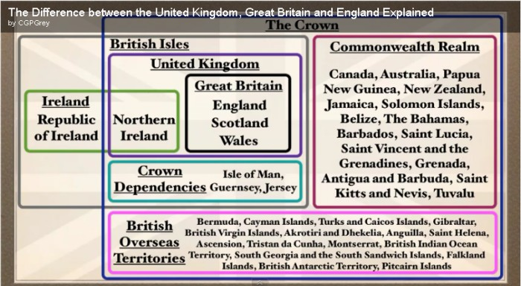
2. Read and translate the text.
United Kingdom
England has existed as a unified entity since the 10th century. The Union between England and Wales was enacted under the Statute of Rhuddlan in 1284. In the Act of Union of 1707, England and Scotland agreed to permanent union as Great Britain; the legislative union of Great Britain and Ireland was implemented in 1801, with the adoption of the name the United Kingdom of Great Britain and Ireland, but in 1921, the Anglo-Irish treaty formalized a partition of Ireland, although six northern Irish counties remained part of the United Kingdom and became known as Northern Ireland and the current name of the country is the United Kingdom of Great Britain and Northern Ireland. It was adopted in 1927.
Great Britain was the dominant industrial and maritime power of the 19th century. It played a leading role in developing parliamentary democracy and in advancing literature and science. At its zenith, the British Empire stretched over one-fourth of the earth's surface.
United Kingdom is one of five permanent members of the UN Security Council, a founding member of NATO, and of the Commonwealth, a member of the EU, but still remains outside the European Monetary Union. In 1999 the Scottish Parliament, the National Assembly of Wales, and the Northern Ireland Assembly were established. And it is a significant issue in the UK.
United Kingdom is located in the Western Europe, on the British Islands, including the northern one-sixth of the island of Ireland, between the North Atlantic Ocean and the North Sea, northwest of France. Total territory is 244,820 sq km. It has a border with Ireland. Its climate is temperate, moderated by prevailing southwest winds over the North Atlantic Current. The landscape of UK is mostly rugged hills and low mountains. Nowadays United Kingdom lies near vital North Atlantic sea lanes, only 35 km from France and linked by tunnel under the English Channel.
The lowest point is Fenland — 4 m; the highest one is Ben Nevis 1,343 m. Its natural resources are coal, petroleum, natural gas, tin, limestone, iron ore, salt, clay, chalk, gypsum, lead.
Official languages are English, Welsh (about 26 % of the population of Wales) and Scottish, as a form of Gaelic (about 60,000 in Scotland).
Government type is constitutional monarchy. Administrative divisions of UK are the following:
England is divided into 47 boroughs, 36 counties, 10 districts;
North Ireland is divided into 24 districts, 2 cities, 6 counties;
Scotland is divided into 32 council areas;
Wales is divided into 11 county boroughs, 9 counties and dependent areas.
The Chief of the state is Queen Elizabeth П since 6 February 1952; the Heir of the Crown is Prince Charles, the son of the queen. He was born on 14 November 1948.
The Head of government is Prime Minister Tony BLAIR since 2 May 1997.
Vocabulary:
to exist — существовать; находиться в природе, жить
entity — сообщность; объект; организация
to enact — предписывать, определять, устанавливать; вводить закон; постановлять
permanent — постоянный, перманентный
to implement — выполнять, осуществлять; обеспечивать выполнение
adoption — принятие; усвоение
partition — деление, раадел, разделение
county — графство (административно-территориальная единица в Англии)
to remain — оставаться ч current — текущий, данный, современный; течение
maritime — морской
zenith — зенит
to stretch — иметь протяжение, простираться, тянуться
the Commonwealth — Содружество (свободное объединение независимых государств, не имеющее общего договора или конституции)
the European Monetary Union — Европейский монетный союз
issue — исход, результат (чего-л.); спорный вопрос, предмет спора, разногласие; проблема
border — граница
temperate — умеренный (о климате и т. п.)
to moderate — ослаблять, смягчать
to prevail — преобладать, господствовать, превалировать; доминировать
landscape — ландшафт, пейзаж
rugged — пересеченный, заваленный, труднопроходимый (о местности)
coal — уголь
petroleum — нефть
limestone — известняк
iron ore — железная руда
clay — глина, глинозем
chalk — мел
gypsum — гипс
lead — свинец
borough — район; городок, небольшой город
heir — наследник, преемник
3. Answer the questions:
1. How long has England existed as a unified entity?
2. When was the union between England and Wales enacted?
3. When was the legislative union of Great Britain and Ireland implemented?
4. When was the name the United Kingdom of Great Britain and Northern Ireland adapted?
5. What is Northern Ireland?
6. Was Great Britain the dominant industrial and maritime power of the 17th century?
7. Is there a connection between France and Great Britain today?
8. Is the United Kingdom a member of the European Monetary Union?
9. Where is the United Kingdom located?
10. What climate has the United Kingdom?
11. What landscape has Great Britain?
12. What are the lowest and the highest points of the country?
13. What are official languages in Great Britain?
14. What are the natural resources?

Практическая работа №24

Тема 3.8. Музыка, литература, писатели

Цель: совершенствование и развитие навыков устной и письменной речи, навыков чтения и перевода текста профессиональной направленности на английском языке.

1. Make up sentences and translate the quotations of famous people:
Example: I / cannot /live / without/ reading / (Thomas Jefferson).
A. are/Words / the voice/ of the/ heart / (Confucius).
B. what exercise / Reading/ is/ to the mind/ is/ to the body/ (Richard Steel).
C. that /People / prefer say / life / is/ the thing / but / I / reading / (Logan Pearsall Smith)
D. in order to /Read / live? (Gustavo Flaubert)
A. is / the best / learning /Reading / (A. Pushkin)
B. is / best / to burn / old wine / to drink / old friend / to trust / and / old authors / to read/ Old wood (F. Bacon)
2. Read the text “Charles Dickens” and do the task.
Charles Dickens (1812-1870)
Charles Dickens is one of the greatest English novelists. His books describe old Victorian England and show how hard it was, especially for the poor and for the children. They include "The Pickwick Papers" («Записки Пиквикского клуба), "Oliver Twist", "A Christmas Carol", "David Copperfield", "Great Expectations" and "A Tale of Two Cities." He came of a petty bourgeois family. In his childhood Dickens discovered a little library in an upstairs room in Portsmouth and read all the books in it.
His father was a clerk and he could never make both ends meet and was thrown into debtors' prison. According to the law of that time a man imprisoned for debt could have his family to live with him in prison. His mother and children stayed in prison. Little Charles was sent to work. He stuck labels on blacking bottles. When his father was set free, the boy left his dirty work and was sent to school. Soon he entered the lawyer's office. At 19 he became a reporter.
He began to write sketches of the characters he observed and in 1836 they were collected in the book "Sketches by Boz". In 1837 the novel "The Pickwick Papers" was published. The book brought him fame and money. All his novels are full of sympathy and human suffering. In "Little Dorrit" he attacks debtors' prisons. In "Hard Times" he describes the most terrible conditions under which not only grown-ups but also little children were working in the mines and cotton mills. In "Oliver Twist" he draws attention to the misery of life in the slums of London. His petty bourgeois sentimentality found expression in the happy endings of almost all his novels. Dickens's novels offer a complete realistic picture of the English bourgeois society of the mid - nineteenth century and are highly valued for their realism and humanity. Dickens died in 1870 and was buried in Westminster Abbey, as he wished with nothing on his gravestone except his name "Charles Dickens".
3. Choose the right answer.
1. Charles Dickens was an English...
a) humourist; b) novelist; c) poet; d) essayist.
2. He was born in...
a) Elizabethan England; b) Victorian England; c) Modern England; d) Old England.
3. He wrote...
a)"Oliver Twist", "David Copperfield", "Pickwick papers";
b)"Romeo and Juliet", "Othello","Macbeth".
c)"Murder on the Orient Express", "Death on the Nile".
4. In his childhood Charles Dickens discovered...
a) treasures; b) a purse; c) a way; d) a little library.
5. Charles Dickens's novels are highly valued for...
a) the beauty of their style;
b) their brilliant (English) language;
c) realism and humanity;
d) the description of the terrible conditions of living in England of that time.
4. Learn the names of musical instruments: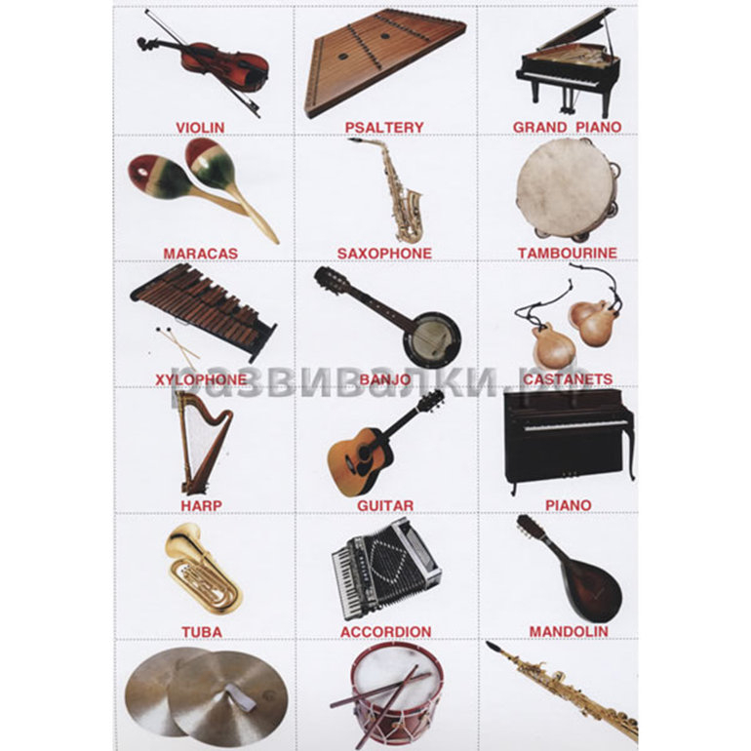

Критерии самооценки выполненной работы:Very well OK A little

НОРМЫ ОЦЕНКИ ЗНАНИЙ, УМЕНИЙ, НАВЫКОВ ОБУЧАЮЩИХСЯ ПО ИНОСТРАННОМУ ЯЗЫКУ
Оценка | Характеристика ответа
 | Монологическая форма | Диалогическая форма
5 | - Учащийся логично строит монологическое высказывание в соответствии с коммуникативной задачей, сформулированной в задании.  - Лексические единицы и грамматические структуры используются уместно.  - Ошибки практически отсутствуют.  - Речь понятна: практически все звуки произносятся правильно, соблюдается правильная интонация.  - Объём высказывания не менее 7-8 фраз. | - Учащийся логично строит диалогическое общение в соответствии с коммуникативной задачей; демонстрирует умения речевого взаимодействия с партнёром: способен начать, поддержать и закончить разговор.  - Лексические единицы и грамматические структуры соответствуют поставленной коммуникативной задаче.  - Ошибки практически отсутствуют.  - Речь понятна: практически все звуки произносятся правильно, соблюдается правильная интонация.  - Объём высказывания не менее 5-6 реплик с каждой стороны.
4 | - Учащийся логично строит монологическое высказывание в соответствии с коммуникативной задачей, сформулированной в задании.  - Лексические единицы и грамматические структуры соответствуют поставленной коммуникативной задаче.  - Учащийся допускает отдельные лексические или грамматические ошибки, которые не препятствуют пониманию его речи.  - Речь понятна, учащийся не допускает фонематических ошибок.  - Объём высказывания не менее 7-8 фраз. | - Учащийся логично строит диалогическое общение в соответствии с коммуникативной задачей.  - Учащийся в целом демонстрирует умения речевого взаимодействия с партнёром: способен начать, поддержать и закончить разговор.  - Используемый словарный запас и грамматические структуры соответствуют поставленной коммуникативной задаче.  - Могут допускаться некоторые лексико-грамматические ошибки, не препятствующие пониманию.  - Речь понятна: практически все звуки произносятся правильно, в основном соблюдается правильная интонация.  - Объём высказывания не менее 5-6 реплик с каждой стороны.
3 | - Учащийся логично строит монологическое высказывание в соответствии с коммуникативной задачей, сформулированной в задании.  Но:  - высказывание не всегда логично, имеются повторы.  - Допускаются лексические и грамматические ошибки, которые затрудняют понимание.  - Речь в целом понятна, учащийся в основном соблюдает правильную интонацию.  - Объём высказывания – менее 5 фраз. | - Учащийся логично строит диалогическое общение в соответствии с коммуникативной задачей. Однако учащийся не стремится поддерживать беседу.  - Используемые лексические единицы и грамматические структуры соответствуют поставленной коммуникативной задаче.  - Фонематические, лексические и грамматические ошибки не затрудняют общение.  Но:  - встречаются нарушения в использовании лексики.  - Допускаются отдельные грубые грамматические ошибки.  - Объём высказывания – менее 4 реплик с каждой стороны.
2 | - Коммуникативная задача не выполнена.  - Допускаются многочисленные лексические и грамматические ошибки, которые затрудняют понимание.  - Большое количество фонематических ошибок. | - Коммуникативная задача не выполнена.  - Учащийся не умеет строить диалогическое общение, не может поддержать беседу.  - Используется крайне ограниченный словарный запас, допускаются многочисленные лексические и грамматические ошибки, которые затрудняют понимание.  - Большое количество фонематических ошибок.

Список рекомендуемой литературы:
1.Агабекян И.П. Английский язык для средних профессиональных заведений. Ростов-на-.Дону: Феникс, 2009. – 319 с.
2. Безкоровайная Г.Т., Соколова Н.И., Койранская Е.А. и др. Planet of English: Учебник английского языка для учреждений НПО и СПО: (+CD): Рекомендовано ФГАУ «Фиро», 2008. - 256
3. Голубев А.П., Балюк Н.В., Смирнова И.Б. Английский язык: Учебник: Рекомендовано
ФГАУ «Фиро». М.: Издательский центр «Академия», 2008. – 336 с
4. Ломаев Б.Ф., Томских Г.П., Михина А.Э. English: Your way. Практический курс английского языка. Чита, 2011. – 300с.

Интернет – ресурсы.
- http://www.lanR.ru English Online - ресурсы для изучения английского языка;
- http://www.englishonline.co.uk - ресурсы для изучения английского языка;

Горобец С.И.

МЕТОДИЧЕСКИЕ УКАЗАНИЯ
ДЛЯ СТУДЕНТОВ
ПО ВЫПОЛНЕНИЮ ПРАКТИЧЕСКИХ ЗАДАНИЙ

УЧЕБНАЯ ДИСЦИПЛИНА
АНГЛИЙСКИЙ ЯЗЫК

